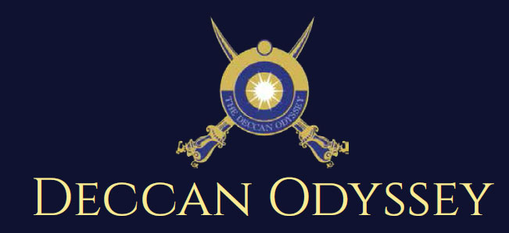

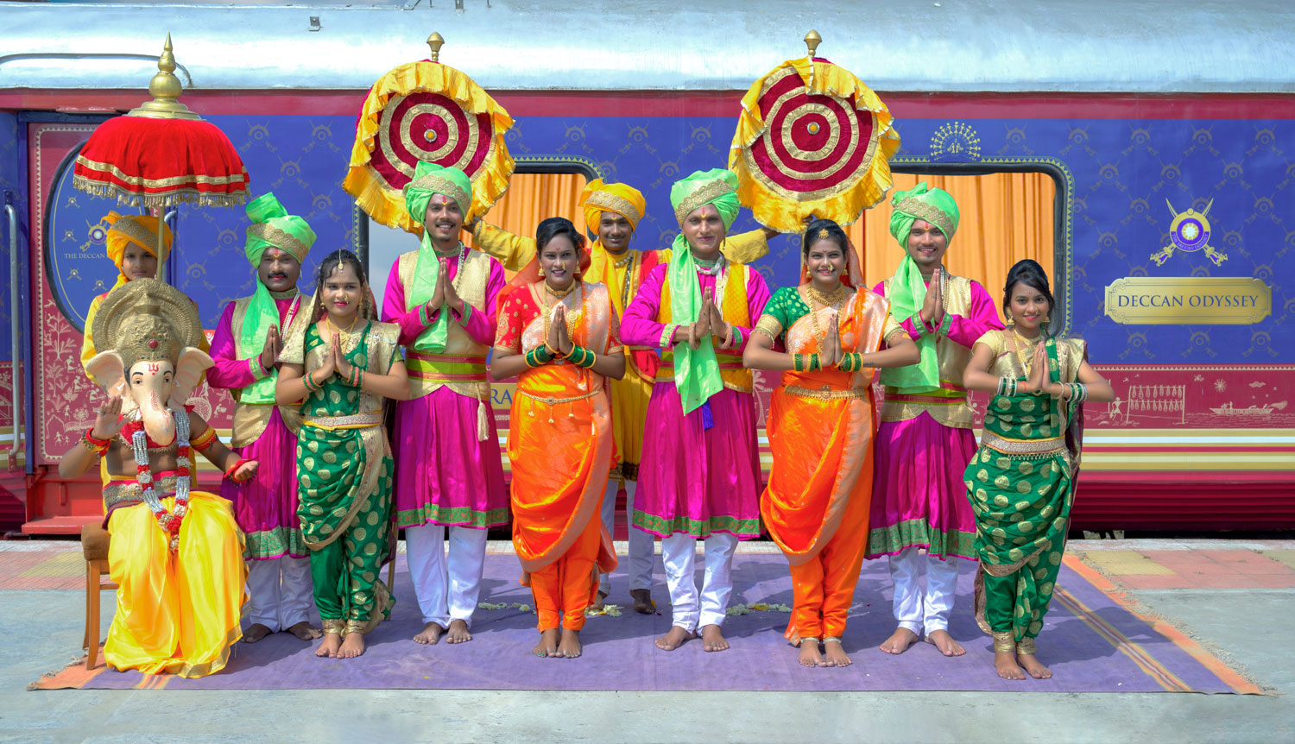

There's something unique about trains. They make you nostalgic. They transport us to far off places and we every day wake up to a new land of mystic and wonders. Trains are home to countless stories.

"Mickey Mouse popped out of my mind onto a drawing pad 20 years ago on a train ride from Manhattan to Hollywood at a time when business fortunes of my brother Roy and myself were at lowest ebb and disaster seemed right around the corner".

Walt Disney

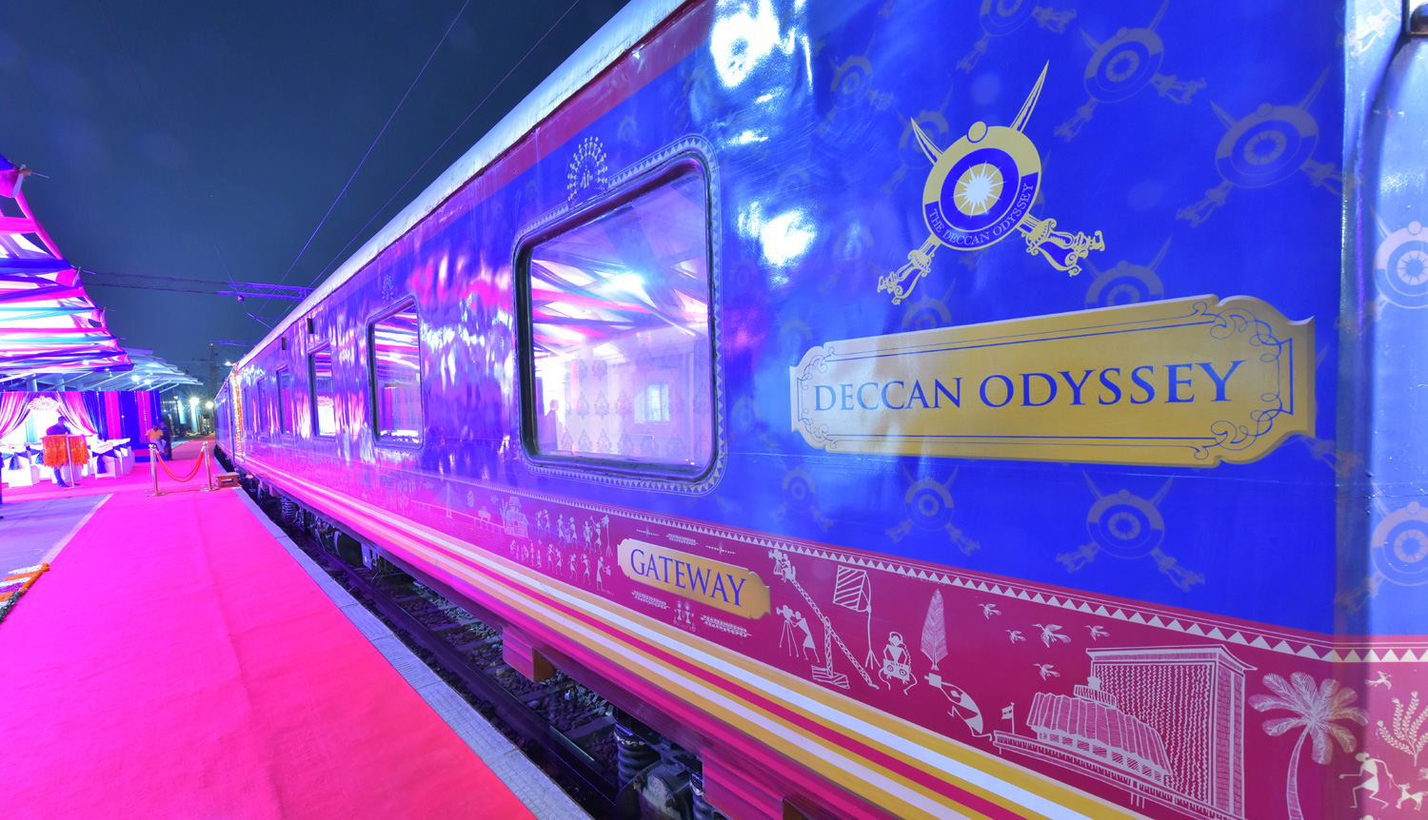

A journey that remains, magical and memorable. The Deccan Odyssey Train Routes and journeys designed to discover the art, architecture, culture, history and wildlife in style. Choose from set of excellent journeys that take you through different parts of India.

TRAIN LAYOUT
Passenger Cars (4 Coupes per Coach) (10)
Presidential Suite Cars (2 Coupes per Coach) (02)
Conference Car with Business Centre (01)
Restaurant Cars (02)
Staff, spare car (02)
Spa Car (01)
Bar Car (01)
Generator Cars with Luggage Store (02)
Total Coaches- 21 -
It can accommodate 88 guests at a time

PRESIDENTIAL SUITE

Dimensions  Cabin Area: 191 Sq Ft  Cabin Length: 8.4 meter  Cabin Width: 2.3 meter  Bed Length: 2.0 meter  Bed Width:0.9 meter  Cabin per Coach: 2 | Private attached bathroom with shower; channel music facility; Individual temperature control panel; direct dial telephone; electronic safe & small cupboard; Presidential suite cabins have a master bedroom with spacious living area, two bathrooms, Personal butler available in each sleeper carriage 24hrs.

DELUXE CABIN

Dimensions  Cabin Area: 95 Sq Ft  Cabin Length: 3.97 meter  Cabin Width: 2.3 meter  Bed Length: 2.0 meter  Bed Width:0.9 meter  Cabin per Coach: 4 | Deluxe Coach features 4 Double/ Twin bed cabins. Direct dial phone, electronic safe, and individual climate control facility. Bathrooms come fitted with wash basin & shower, shower cubicle and running hot and cold water; Twin bed is 6' x 3'. Specially equipped cabin, for the comfort of our diﬀerently-abled guests.

RESTAURANTS

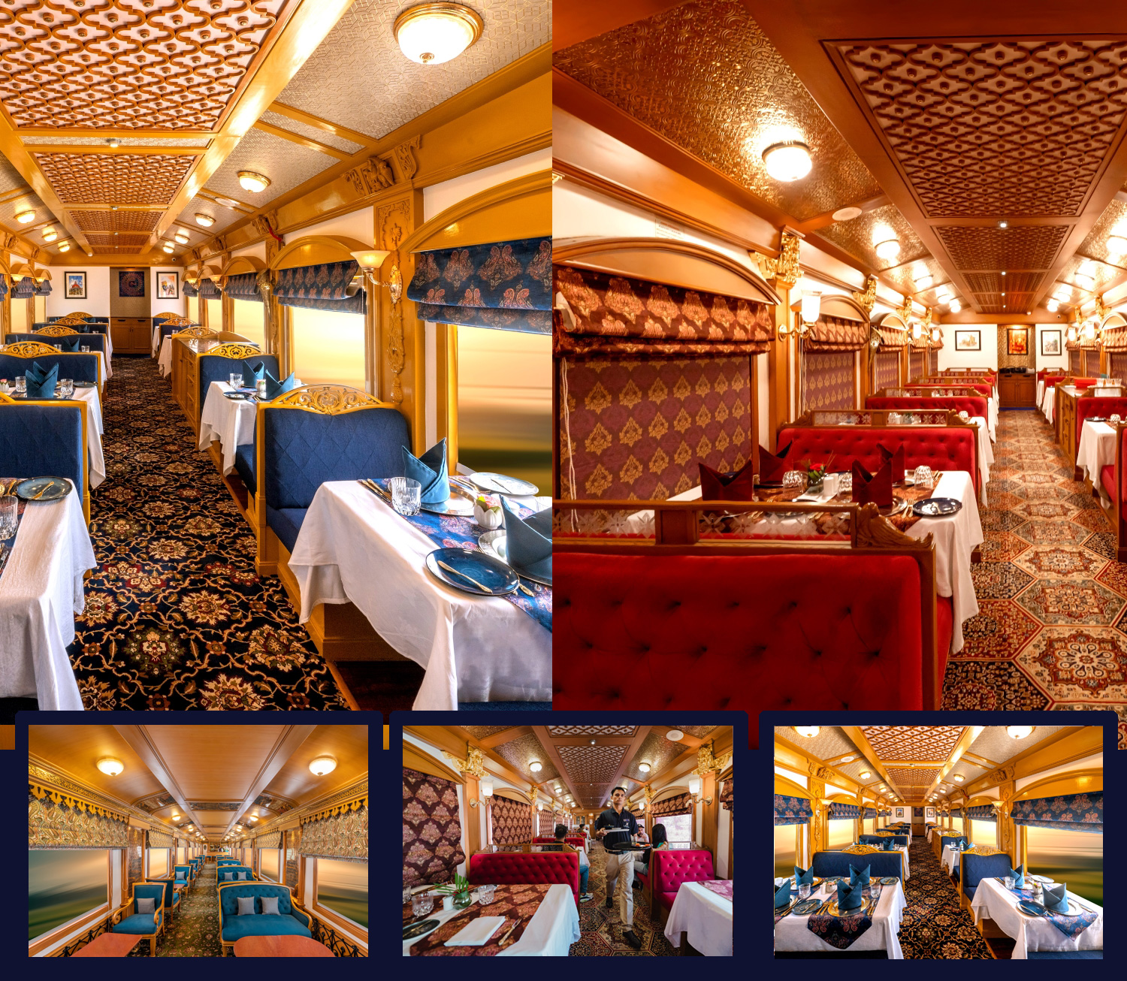
The Deccan Odyssey's two gourmet restaurants, Waavar and Utsav have been designed to keep the element of Indian royalty intact. Our chefs ensure the cuisine keeps pace with the train's journey, by creating local specialties of the every state that the train travels through. So you discover every location with all your senses, including your taste buds! Each meal also includes an International menu to choose from. To further enhance the gourmet experience, Deccan Odyssey presents travelers with a well-stocked bar - Gateway. This is the ideal spot to meet and know your fellow travelers, over an evening drink & snacks.

GATEWAY BAR
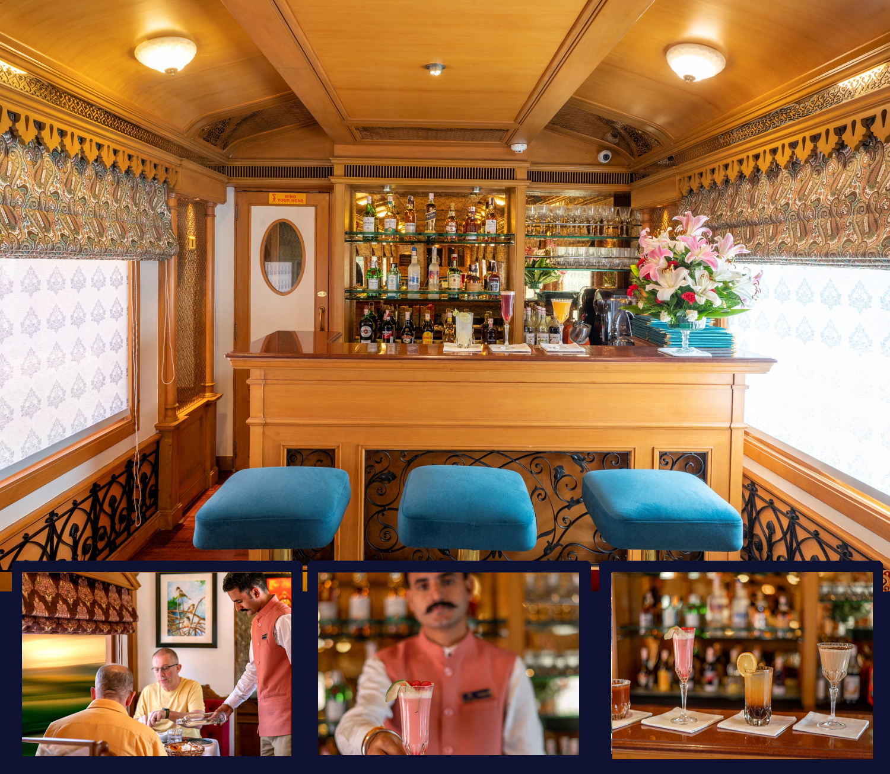
A Well-Stocked Bar with TV Facility serves Wine, Liquor and Spirits of Indian and International make.

CONFERENCE CAR
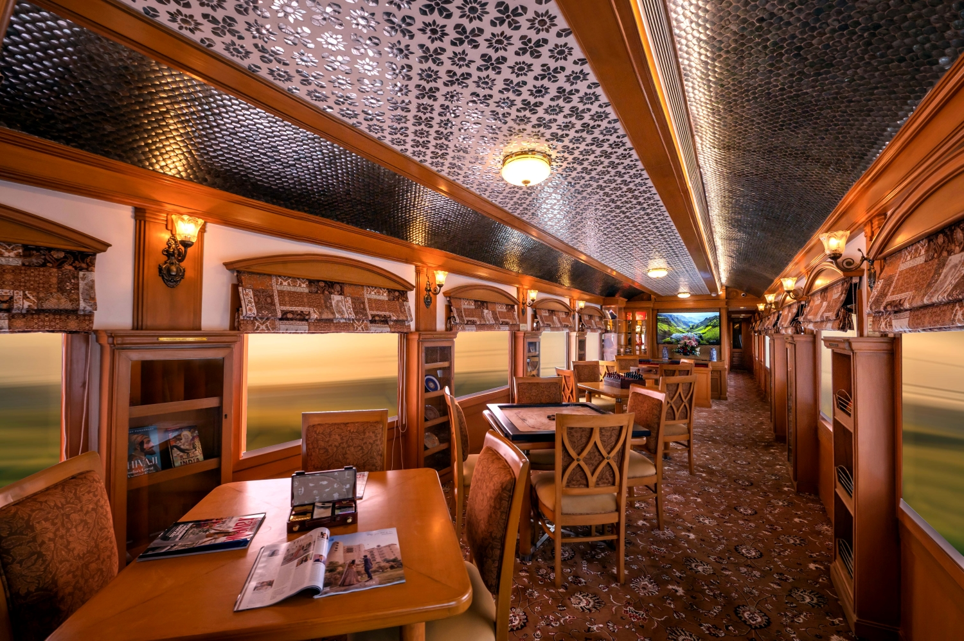
If work requires your time and attention, then our conference car, "Pankh" will take care of all your business needs. Equipped with the latest facilities, it ensures you manage your work efficiently even while you're away travelling.

SPA CAR

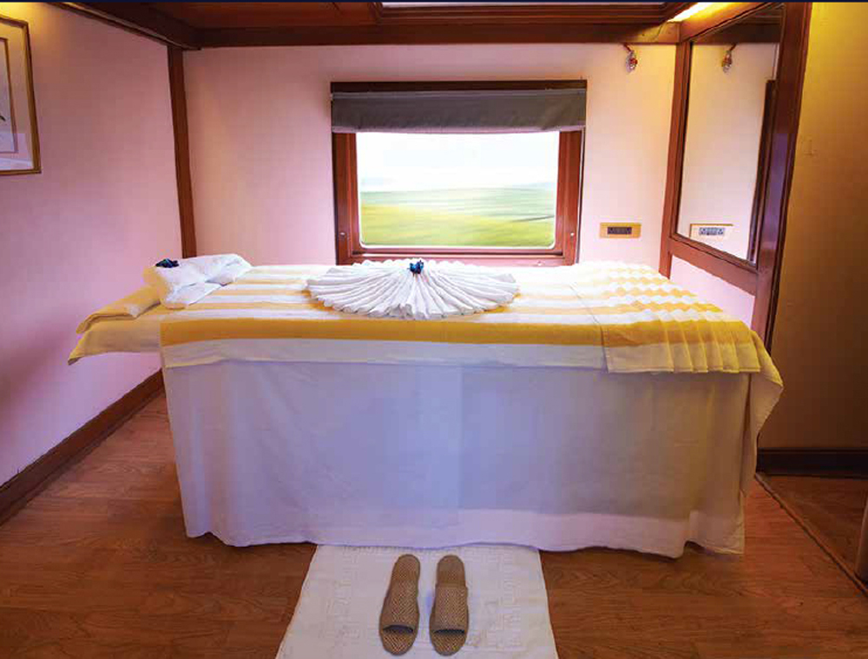

After a long day of exploration, head to Deccan Odyssey's wonderful spa "Ayush". The salon's well-trained masseurs, incorporate ancient Indian techniques to help you relax your body and rejuvenate your mind.

MAHARASHTRA WILD TRAIL

Destinations Covered:

Mumbai | Ellora Caves | Aurangabad | Pench (Ramtek) | Tadoba | Ajanta | Nashik |Mumbai

Duration:
07 Nights / 08 Days

MAHARASHTRA WILD TRAIL
Day 1 (Saturday): MUMBAI
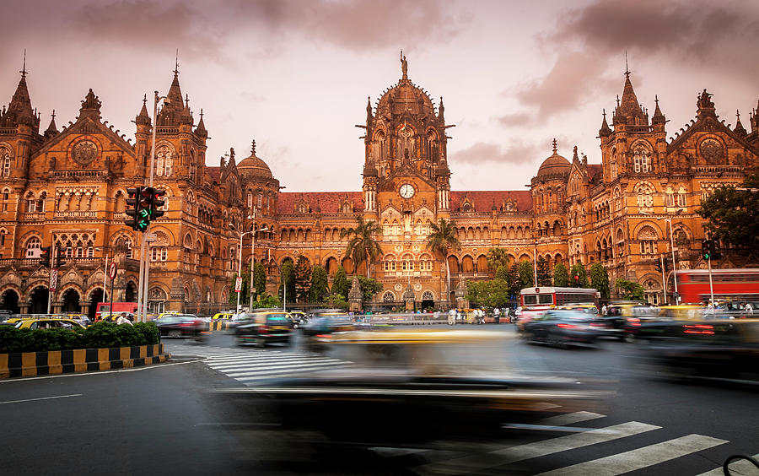
Welcome aboard the Deccan Odyssey.
Early this evening assemble at the Chhatrapati Shivaji Terminus at approximately 1530 hours to complete the registration process and check in formalities for your Maharashtra Wild Trail journey, as you receive a traditional Indian welcome and enjoy a refreshing welcome drink.
After completion of all formalities, you will be shown to your delightful cabins. As you settle in, the Deccan Odyssey shall depart Mumbai for Ellora Caves.
Dinner on board
Overnight on Deccan Odyssey
(ETD at 1930 Hrs)
(ETD at 1640 Hrs)

Day 2 (Sunday): ELLORA CAVES
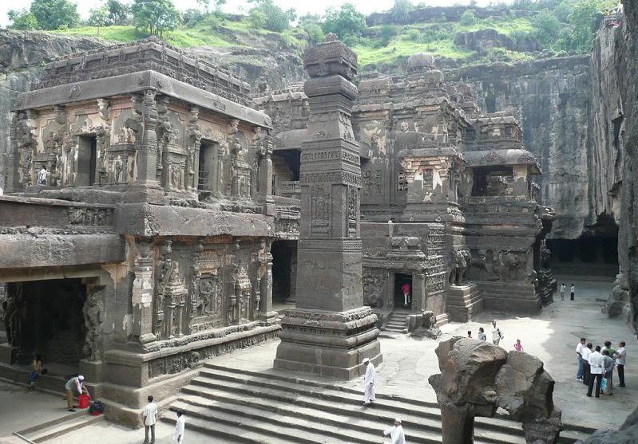
As you enjoy breakfast, the Deccan Odyssey arrives at Aurangabad, named after the last Great Mughal Aurangzeb, an industrial town in Maharashtra and the stop from where to head out to visit the exceptional Ellora Caves, a World Heritage site. The city itself has deep Mughal influences and there are several monuments of note here; the Daulatabad Fort, Bibi-ka-Maqbara and the city’s 52 gates, each with its own history, amongst them.
The morning is at leisure on board or you may choose the option of enjoying a relaxing massage at a hotel spa. Post an early lunch, disembark for a scenic drive that takes you to the Ellora Caves, carved into the side of a basaltic hill 30 km from the city. The finest specimen of cave-temple architecture in India, the site encompasses 34 rock-cut shrines representing Buddhist, Jain and Hindu art dating from the 4th to 5th century AD.

Next climb up to explore the lofty Daulatabad fort, occupied since at least 100 BCE, and which houses the remains of Buddhist caves similar to those at Ajanta and Ellora.
You will then return to the Deccan Odyssey to freshen up before heading back to the city for dinner.
Breakfast, Lunch and Dinner on Board

Overnight on Deccan Odyssey

Day 3 (Monday): AURANGABAD
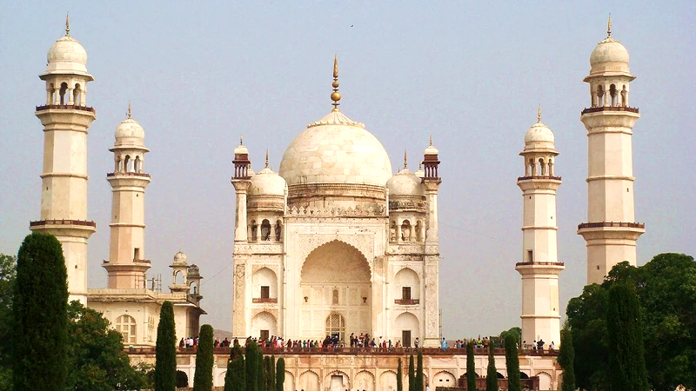
This morning enjoy a leisurely breakfast before heading out to the Old City of Aurangabad.
Spend the morning visiting Bibi-ka-Maqbara, the mausoleum of Dilras Banu, Aurangzeb’s wife, and a replica of the Taj Mahal at Agra. Built between 1651 and 1661 by her son, Prince Azam Shah, the monument is also called the ‘Taj of the Deccan’ and was intended to rival the splendor of the Taj Mahal, but unfortunately fell short.
Next visit a facility that specialises in the weaving of Himroo fabric. The fabric of choice for the royalty of that age, Himroo has been associated with Aurangabad since the 14th century, when Muhammad Tughlaq made it his capital. Himroo features Persian designs woven with gold and silver threads and takes its name from Hum-ruh, which means ‘similar’ in Persian, as it is a replica of the Kum Khwab fabric that was popular in royal courts before Himroo gained precedence.
Return to the Deccan Odyssey for lunch on board after which you can enjoy the rest of your afternoon indulging in the recreational activities on board as the hinterland of Maharashtra sweeps past, with its ever-changing colors and landscape making its way to Ramtek for Pench National Park.
In the evening, enjoy a sun downer at the Mumbai-Hi before dinner is served.

Breakfast, Lunch and Dinner on Board
Breakfast, Lunch and Dinner on board
Overnight on Deccan Odyssey
(ETD at 1300 Hrs)

Day 4 (Tuesday): PENCH – RAMTEK
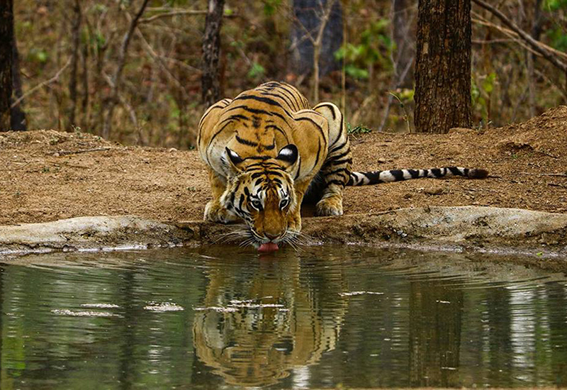
Awaken before sunrise today as the Deccan Odyssey pulls into Ramtek, for your date with nature’s beautiful creations at the Pench National Park. Named after the Pench River, which meanders through it like a mammoth python, splitting it into almost equal halves, the park is immensely rich in biodiversity, its terrain defined by hills, valleys and the occasional precipitous slope, an important ecosystem supporting an abundance of flora and fauna, including a rich variety of aquatic life.
After an exhilarating game drive, return to the Deccan Odyssey for a leisurely brunch on board.
Disembark again in the afternoon for your second adventure into the wild. The Pench National Park is four different forest regions in one, an extravagance of trees, shrubs, grasses, climbers, weeds and herbs, with teak being the most prominent of the tree species. Birdlife here is equally bountiful, the feathered denizens of Pench including both resident and migratory birds like Malabar pied hornbills, Indian pittas, ospreys, white-eyed buzzards, storks, waterfowls, four endangered vulture species, and the green pigeon, which is the State Bird of Maharashtra.
After an exciting day at Pench drive back to Ramtek station to board the Deccan Odyssey. Enjoy a sumptuous dinner as the Deccan Odyssey departs for Tadoba, the land of the mighty tigers.

Breakfast, Lunch and Dinner on Board
Overnight on Deccan Odyssey
(ETD at 2000 Hrs)

Day 5 (WEDNESDAY): TADOBA
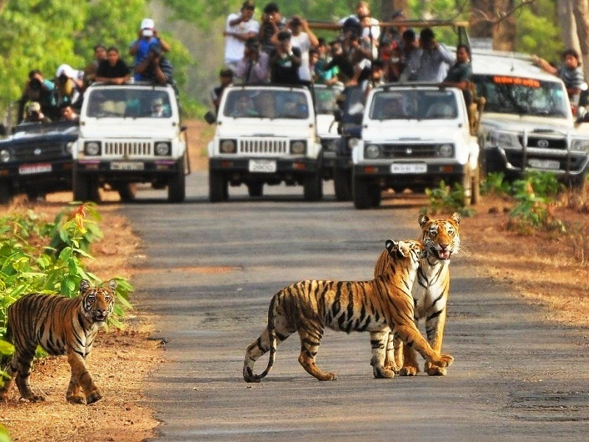
Wake up before the sun this morning as the Deccan Odyssey rolls back into Chandrapur station, for your early morning safari into the Tadoba Tiger Reserve, also called the Land of Tigers, for its high tiger density. It is not uncommon to spot tigers and wild dogs here, with plenty of opportunities for close encounters with leopards, sloth bears, gaurs (the Indian bison), the rusty spotted cat, ratels, various species of deer, wild pigs and more.
After an exciting morning, a late breakfast will be served at the Tiger Trails lodge, following which you can relax, view a documentary on wildlife or interact with our naturalist.
Enjoy lunch at the lodge before you drive back to Chandrapur station to board the Deccan Odyssey.
Sit back, unwind and enjoy cocktails fixed by our bartender onboard, followed by a sumptuous dinner and a well deserved rest as the Deccan Odyssey proceeds towards Jalgaon to visit the exquisite Ellora Caves.
Breakfast, Lunch and Dinner on Board

Overnight on Deccan Odyssey
(ETD at 2000 Hrs)

Day 6 (Thursday): AJANTA CAVES
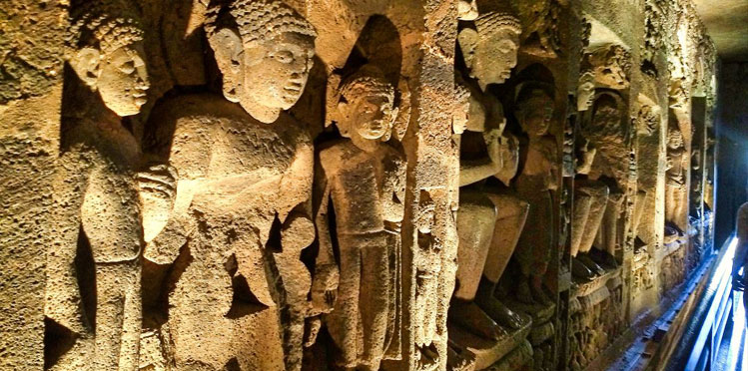
The Deccan Odyssey arrives at the Jalgaon station this morning from where, after breakfast on board, you will disembark and drive to the Ajanta Caves, a World Heritage site and an architectural marvel of its time. The 30 rock-hewn Buddhist caves at Ajanta have been masterfully carved and are adorned with sculptures and paintings of Buddhist religious art, depicting universal pictorial art as well as the fusion of Buddhist and Hindu faith.
After exploring Ajanta, return to the Deccan Odyssey for lunch as it takes you towards Nashik.
The rest of the day is at leisure for you to relax and enjoy some of the activities available on board. Watch a movie, learn the rules of ‘carrom’, a popular Indian board game, from a Deccan Odyssey team member or book yourself a relaxing massage in our spa on board.
Relax and watch the tapestry of rural India unfold as you sip a sun downer before dinner.
Breakfast, Lunch and Dinner on Board

Overnight on Deccan Odyssey
(ETD at 1500 Hrs)

Day 7 (FRIDAY): NASHIK
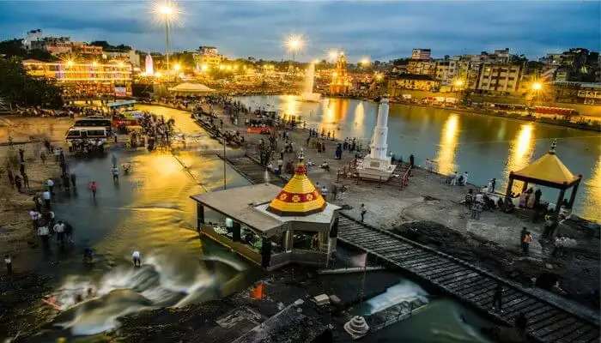
The Deccan Odyssey arrives at the Jalgaon station this morning from where, after breakfast on board, you will disembark and drive to the Ajanta Caves, a World Heritage site and an architectural marvel of its time. The 30 rock-hewn Buddhist caves at Ajanta have been masterfully carved and are adorned with sculptures and paintings of Buddhist religious art, depicting universal pictorial art as well as the fusion of Buddhist and Hindu faith.
After exploring Ajanta, return to the Deccan Odyssey for lunch as it takes you towards Nashik.
The rest of the day is at leisure for you to relax and enjoy some of the activities available on board. Watch a movie, learn the rules of ‘carrom’, a popular Indian board game, from a Deccan Odyssey team member or book yourself a relaxing massage in our spa on board.
Relax and watch the tapestry of rural India unfold as you sip a sun downer before dinner.
Breakfast, Lunch and Dinner on Board
Overnight on Deccan Odyssey
(ETD at 2000 Hrs)

Day 8 (Saturday): MUMBAI
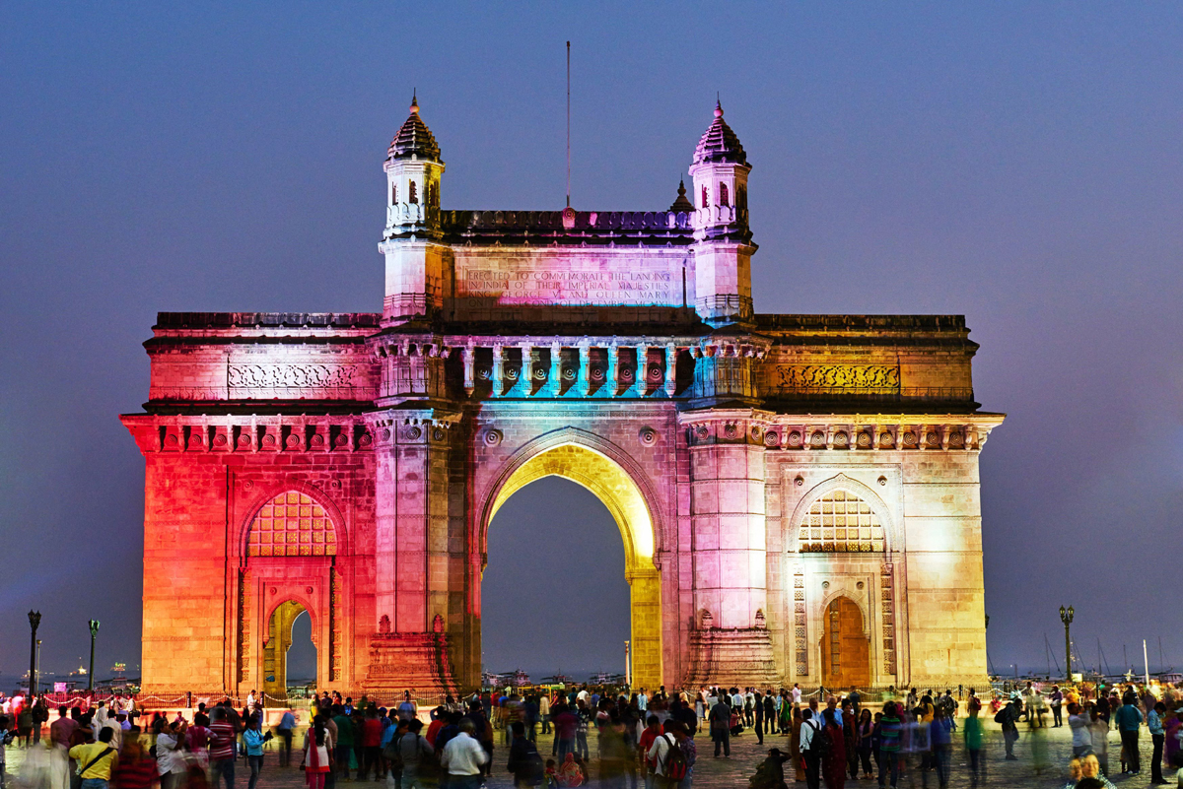
Disembark in Mumbai
Early this morning, after breakfast, you will disembark at Chhatrapati Shivaji Terminus Railway Station, Mumbai.
Bid farewell to the Deccan Odyssey as your royal passage through the grand vistas of India comes to an end.
Breakfast on board

DEPARTURE DATES
2023 | 2024 | 2025 |  | 2026
NA | 04 May  11 MAY  19 October |  | 10 May  17 May | --

TARIFF 2023 –2024 (Per Cabin Per Journey)
Category | Single Occupancy | Double Occupancy | 02 Children  (in a separate deluxe cabin)
Deluxe Cabin | $8,330 | $11,900 | Price on Request
Presidential Suite | $17,850 | $17,850 | Price on Request

TARIFF 2024-2025 (Per Cabin Per Journey)
Category | Single Occupancy | Double Occupancy | 02 Children  (in a separate deluxe cabin)
Deluxe Cabin | $8,330 | $11,900 | Price on Request
Presidential Suite | $17,850 | $17,850 | Price on Request

TARIFF 2025-2026 (Per Cabin Per Journey)
Category | Single Occupancy | Double Occupancy | 02 Children  (in a separate deluxe cabin)
Deluxe Cabin | $9,330 | $13,300 | Price on Request
Presidential Suite | $20,000 | $20,000 | Price on Request

Inclusions | Exclusions
- Accommodation in double / twin bedded cabin with en suite bathrooms  - All meals (B, L, D)  - Soft beverages during the journey  - Valet service  - Still camera fees  - Guided oﬀ train excursions and game drives as illustrated in the itinerary – inclusive of entrance fees, park fees, transport and services of an English-speaking local guide | - Taxes including 5.00% (subject to change as per Govt. directives)  - Government Service tax, Insurance, gratuities  - Laundry and alcoholic Beverages  - Video and professional Still camera fees  - Arrival and Departure transfers  - International and Domestic air tickets  - Pre and Post tour accommodation and any tour extensions unless specifically mentioned as a part of the journey  - All activities mentioned as ‘options’ in the itinerary.
Booking Policy
20% of the tariff: at the time of the confirmation of the booking.
Remaining 80% of the tariff: to be paid 60 days prior to departure
Cancellation Policy
Retention of 10% of ticket value: cancelling 60 days prior to the departure date.
Retention of 20% of ticket value: cancelling 59 – 45 days prior to the departure date
Retention of 50% of ticket value: cancelling 44 – 30 days prior to the departure date
Retention of 100% of ticket value: cancelling 29 – 45 days prior to the departure date
Terms and Conditions
- All Costs are in USD
- The above costs are per cabin per Journey
- As the train runs on the tracks of the Indian Railways, the itineraries are subject to change in case of any changes in the routing
- Prices are subject to change in case of any amendment in the routing or other hikes such as fuel, taxes
- Children below 5 years of age shall be allowed free, subject to sharing of double bed with This is subject to availability of double bed at the time of booking
- Presidential Suite can accommodate up to 3 adults or 2 Adults and 2 children (One child up to 5 years of age and second child up to 12 years of age)
- Government Service tax of 5.00% (subject to change as per Govt. directives) is additional and will be charged extra on the published tariﬀ.
- All Departures and Arrivals are on Tentative basis and are subject to approval from Indian Railways.
- The Entire Deccan Odyssey Train is non-Smoking. For any particular requirement, kindly contact your Valet.
- We need minimum occupancy to operate all listed journeys, in event if we do not manage minimum occupancy we reserve the right to cancel the journey at least with 30 days prior intimation.
- As Train runs on tracks so you may experience sounds of passing trains and some shaking during the journey. This is a normal feature countrywide with trains in India.
- Paramedic on Board
