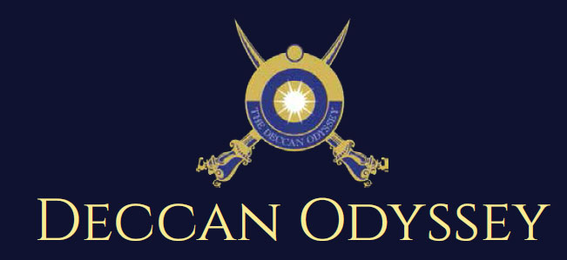
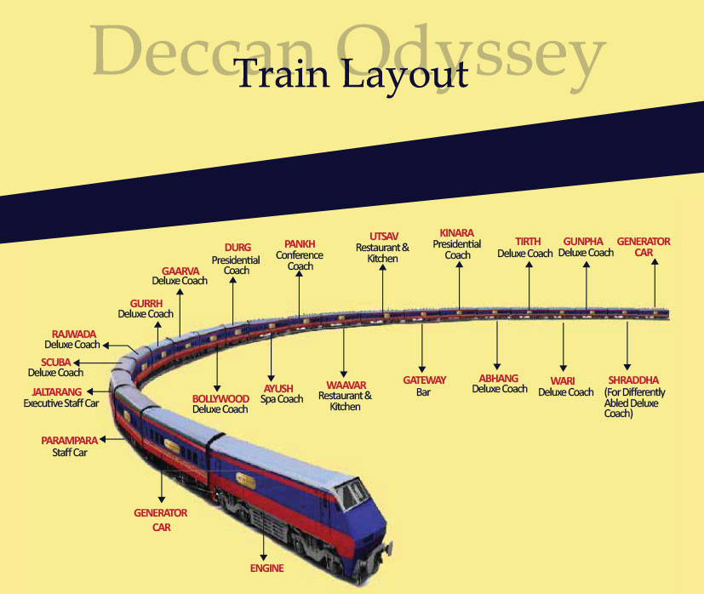
Passenger Cars (4 Coupes per Coach) (10)
Presidential Suite Cars (2 Coupes per Coach) (02)
Conference Car with Business Centre (01)
Restaurant Cars (02)
Staff, spare car (02)
Spa Car (01)
Bar Car (01)
Generator Cars with Luggage Store (02)
Total Coaches- 21 - It can accommodate 88 guests at a time

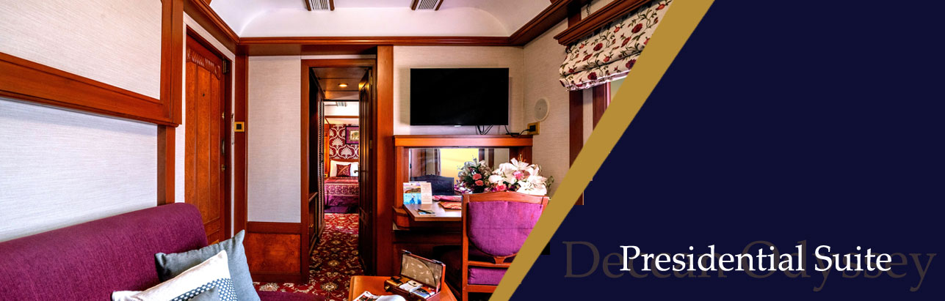
Private attached bathroom with shower; channel music facility; Individual temperature control panel; direct dial telephone; electronic safe & small cupboard; Presidential suite cabins have a master bedroom with spacious living area, two bathrooms, Personal butler available in each sleeper carriage 24hrs.

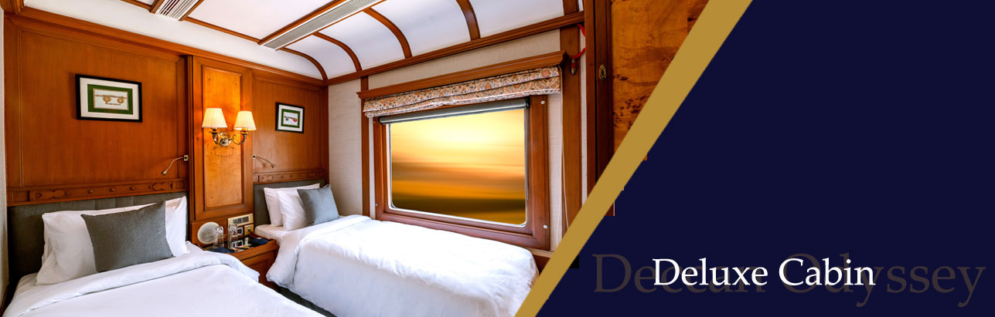
Every Deluxe Coach features 4 Double/ Twin bed cabins. Direct dial phone, electronic safe, and individual climate control facility. Bathrooms come fitted with wash basin & shower, shower cubicle and running hot and cold water; Twin bed is 6' x 3'. Specially equipped cabin, for the comfort of our diﬀerently-abled guests.

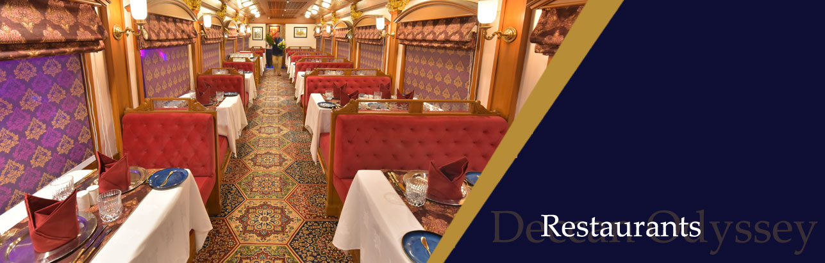
The Deccan Odyssey's two gourmet restaurants, Waavar and Utsav have been designed to keep the element of Indian royalty intact. Our chefs ensure the cuisine keeps pace with the train's journey, by creating local specialties of the very state that the train travels through. So you discover every location with all your senses, including your taste buds! Each meal also includes an International menu to choose from. In order to further enhance the gourmet experience, Deccan Odyssey presents travelers with a well-stocked bar - Gateway. This is the ideal spot to meet and know your fellow travellers, over an evening drink & snacks.
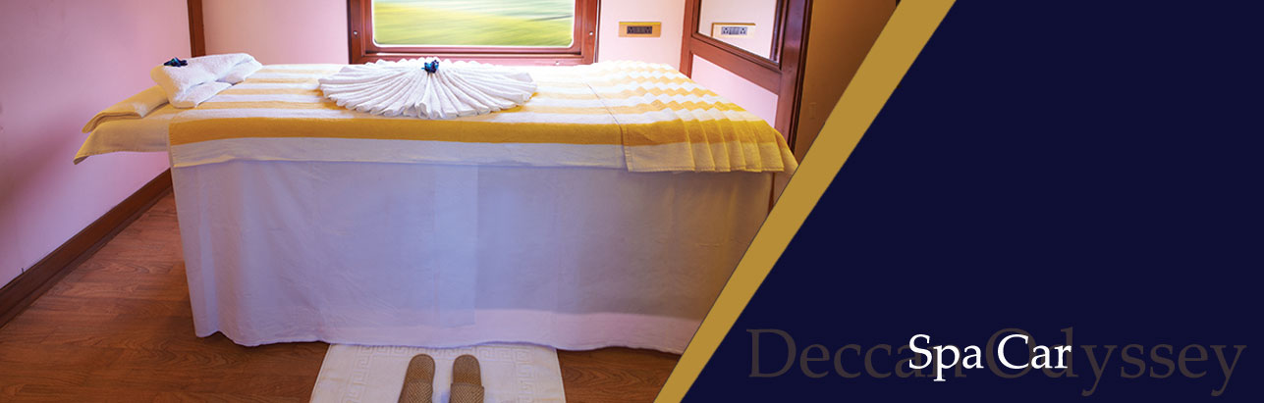
After a long day of exploration, head to Deccan Odyssey's wonderful spa "Ayush". The salon's well-trained masseurs, incorporate ancient Indian techniques to help you relax your body and rejuvenate your mind.

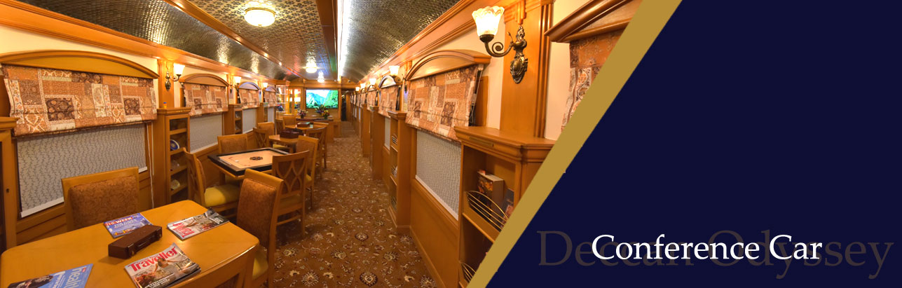
If work requires your time and attention, then our conference car, "Pankh" will take care of all your business needs. Equipped with the latest facilities, it ensures you manage your work efficiently even while you're away travelling.

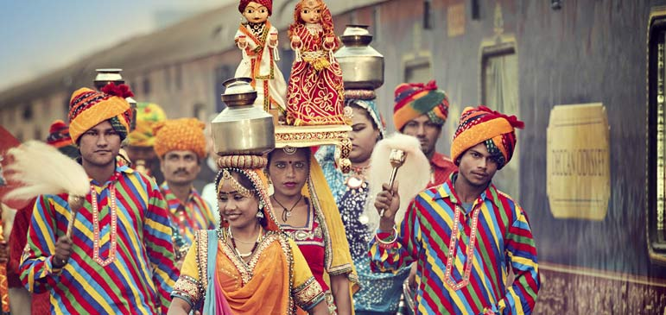
Destinations Covered:  Mumbai | Nashik | Ellora Caves |  Ajanta Caves | Kolhapur | Goa |  Sindhudurg | Mumbai | Duration:  07 Nights / 08 Days
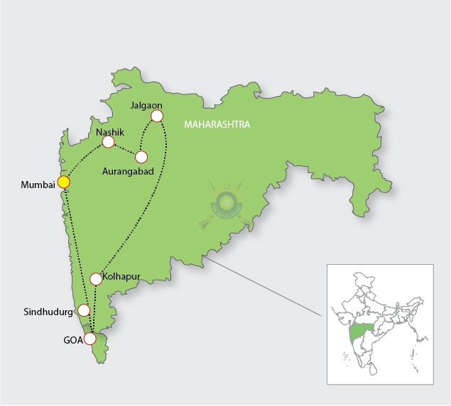

Day 1 (Saturday): MUMBAI  This evening, arrive at Chhatrapati Shivaji Terminus and board the Deccan Odyssey on a mesmerizing voyage through the Maratha heartland.  (Departure at 17:15) | 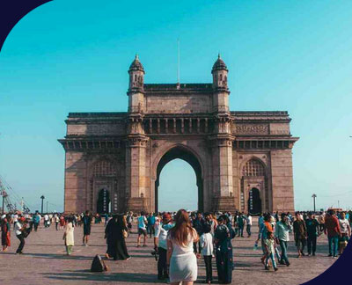
Day 2 (Sunday): NASHIK  Arrive in Nashik and walk along the Godavari Ghats; then head for a vineyard tour followed by wine-tasting and lunch.  (Departure at 19:00) | 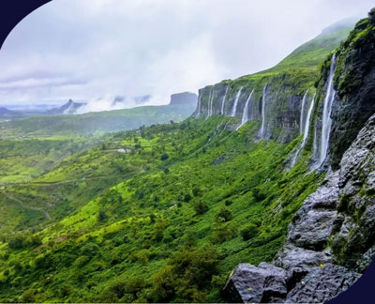
Day 3 (Monday): ELLORA CAVES  Proceed to visit Ellora Caves - a World Heritage site. A unique artistic creation, with its sanctuaries devoted to Buddhism, Hinduism and Jainism, it illustrates the spirit of tolerance that was characteristic of ancient India.  (Departure at 14:30) | 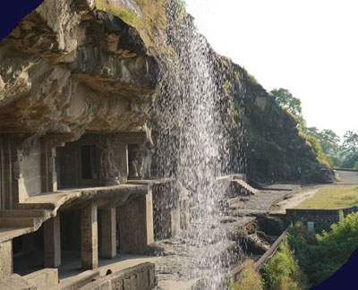
Day 4 (Tuesday): AJANTA CAVES  Arrive at Jalgaon railway station and drive to Ajanta Caves - a World Heritage site. These magnificent caves have exquisite ancient murals & sculptures that depict the life of Buddha.  (Departure at 15:30) | 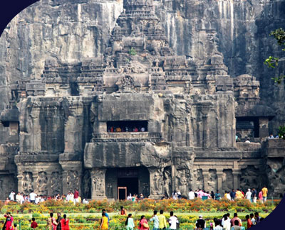
Day 5 (Wednesday): KOLHAPUR  Arrive at Kolhapur, a multifaceted c with a mythical past. Visit the N Palace, the Mahalaxmi Temple and the Town Hall museum. Witness a tradition martial arts performance known 'Mardani Khel'.  (Departure at 19:30) | 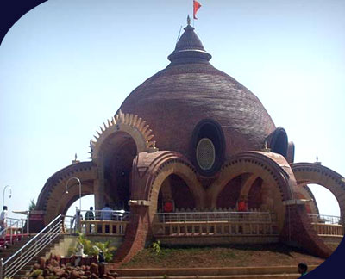
Day 6 (Thursday): GOA  Arrive in Goa, known for its beaches churches and temples. Take a tour of 01 Goa, visiting the ruins of St. Augustine Church & the Basilica of Bom Jesus. Wall through the old Latin Quarters known as Fontainhas.  (Departure at 19:30) | 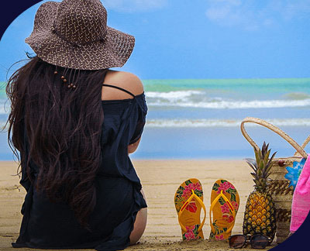
Day 7 (FRIDAY): SINDHUDURG  Arrive in Sindhudurg which lies on a rocky island just off the coast of Malvan.  (Departure at 18:00) | 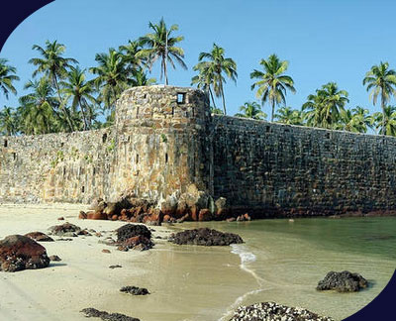
Day 8 (Saturday): MUMBAI

Arrive at Mumbai, where your journey comes to an end.

DEPARTURE DATES
2023 | 2024 | 2025
16 September  04 November | 21 September  12 October  09 November  14 December | 22 March  03 May

TARIFF 2023 – 2024-2025 (Per Cabin Per Journey)
Category | Single Occupancy | Double Occupancy | 02 Children  (in a separate deluxe cabin)
Deluxe Cabin | $8,330 | $11,900 | Price on Request
Presidential Suite | $17,850 | $17,850 | Price on Request

Inclusions | Exclusions
- Accommodation in double / twin bedded cabin with en suite bathrooms  - All meals (B, L, D)  - Soft beverages during the journey  - Valet service  - Still camera fees  - Guided oﬀ train excursions and game drives as illustrated in the itinerary – inclusive of entrance fees, park fees, transport and services of an English-speaking local guide | - Taxes including 5.00% (subject to change as per Govt. directives)  - Government Service tax, Insurance, gratuities  - Laundry and alcoholic Beverages  - Video and professional Still camera fees  - Arrival and Departure transfers  - International and Domestic air tickets  - Pre and Post tour accommodation and any tour extensions unless specifically mentioned as a part of the journey  - All activities mentioned as ‘options’ in the itinerary.
Booking Policy
20% of the tariff: at the time of the confirmation of the booking.
Remaining 80% of the tariff: to be paid 60 days prior to departure
Cancellation Policy
No Cancellation: cancelling 60 days prior to the departure date.
Retention of 20% of ticket value: cancelling 59 – 45 days prior to the departure date
Retention of 50% of ticket value: cancelling 44 – 30 days prior to the departure date
Retention of 100% of ticket value: cancelling 29 – 45 days prior to the departure date
Terms and Conditions
- All Costs are in USD
- The above costs are per cabin per Journey
- As the train runs on the tracks of the Indian Railways, the itineraries are subject to change in case of any changes in the routing
- Prices are subject to change in case of any amendment in the routing or other hikes such as fuel, taxes
- Children below 5 years of age shall be allowed free, subject to sharing of double bed with This is subject to availability of double bed at the time of booking
- Presidential Suite can accommodate up to 3 adults or 2 Adults and 2 children (One child up to 5 years of age and second child up to 12 years of age)
- Government Service tax of 5.00% (subject to change as per Govt. directives) is additional and will be charged extra on the published tariﬀ.
- All Departures and Arrivals are on Tentative basis and are subject to approval from Indian Railways.

