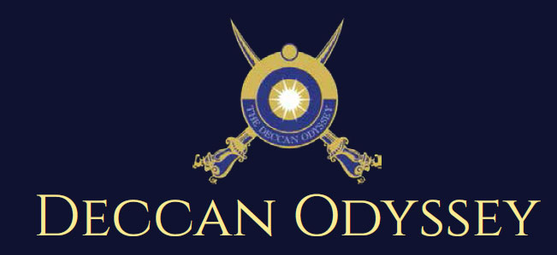

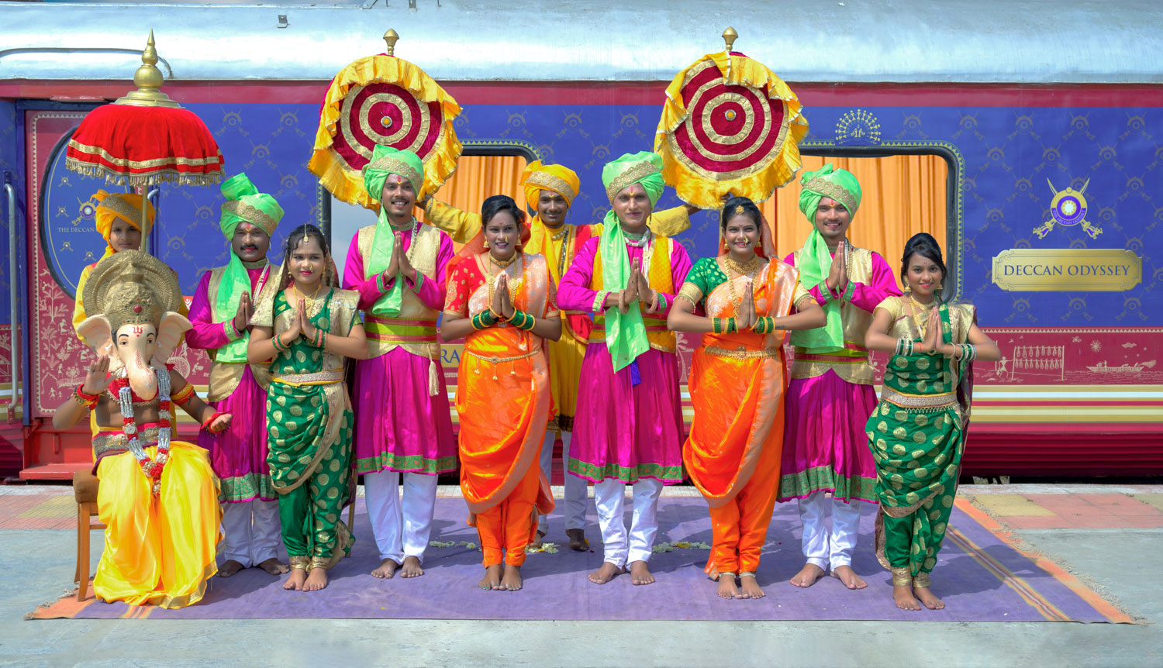

There's something unique about trains. They make you nostalgic. They transport us to far off places and we every day wake up to a new land of mystic and wonders. Trains are home to countless stories.

"Mickey Mouse popped out of my mind onto a drawing pad 20 years ago on a train ride from Manhattan to Hollywood at a time when business fortunes of my brother Roy and myself were at lowest ebb and disaster seemed right around the corner".

Walt Disney

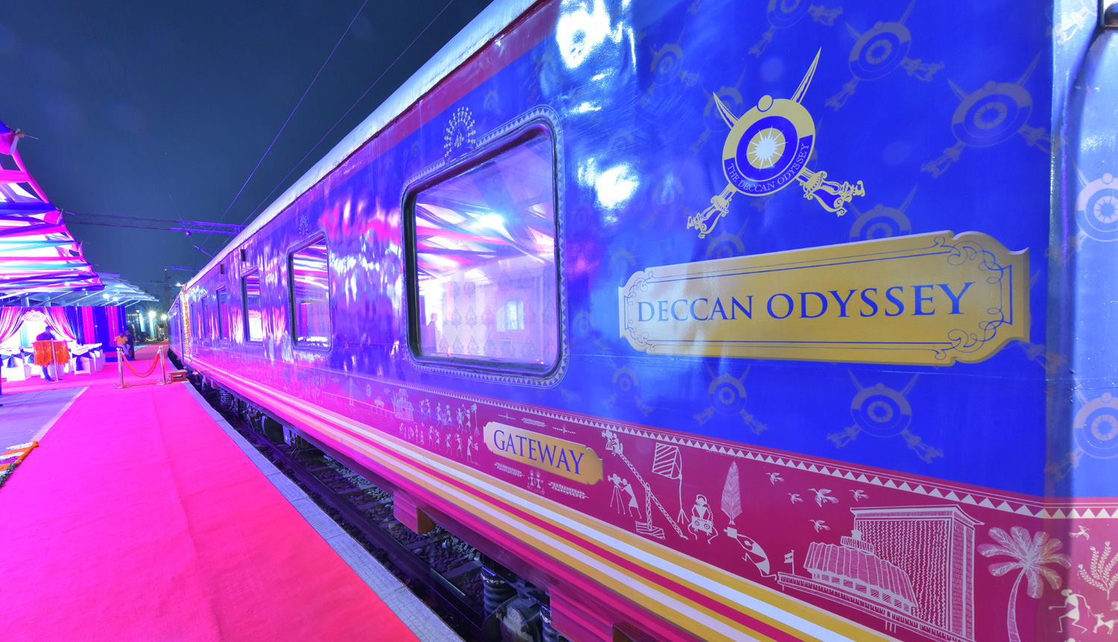

A journey that remains, magical and memorable. The Deccan Odyssey Train Routes and journeys designed to discover the art, architecture, culture, history and wildlife in style. Choose from set of excellent journeys that take you through different parts of India.

TRAIN LAYOUT
Passenger Cars (4 Coupes per Coach) (10)
Presidential Suite Cars (2 Coupes per Coach) (02)
Conference Car with Business Centre (01)
Restaurant Cars (02)
Staff, spare car (02)
Spa Car (01)
Bar Car (01)
Generator Cars with Luggage Store (02)
Total Coaches- 21 -
It can accommodate 88 guests at a time

PRESIDENTIAL SUITE

Dimensions  Cabin Area: 191 Sq Ft  Cabin Length: 8.4 meter  Cabin Width: 2.3 meter  Bed Length: 2.0 meter  Bed Width:0.9 meter  Cabin per Coach: 2 | Private attached bathroom with shower; channel music facility; Individual temperature control panel; direct dial telephone; electronic safe & small cupboard; Presidential suite cabins have a master bedroom with spacious living area, two bathrooms, Personal butler available in each sleeper carriage 24hrs.

DELUXE CABIN

Dimensions  Cabin Area: 95 Sq Ft  Cabin Length: 3.97 meter  Cabin Width: 2.3 meter  Bed Length: 2.0 meter  Bed Width:0.9 meter  Cabin per Coach: 4 | Deluxe Coach features 4 Double/ Twin bed cabins. Direct dial phone, electronic safe, and individual climate control facility. Bathrooms come fitted with wash basin & shower, shower cubicle and running hot and cold water; Twin bed is 6' x 3'. Specially equipped cabin, for the comfort of our diﬀerently-abled guests.

RESTAURANTS

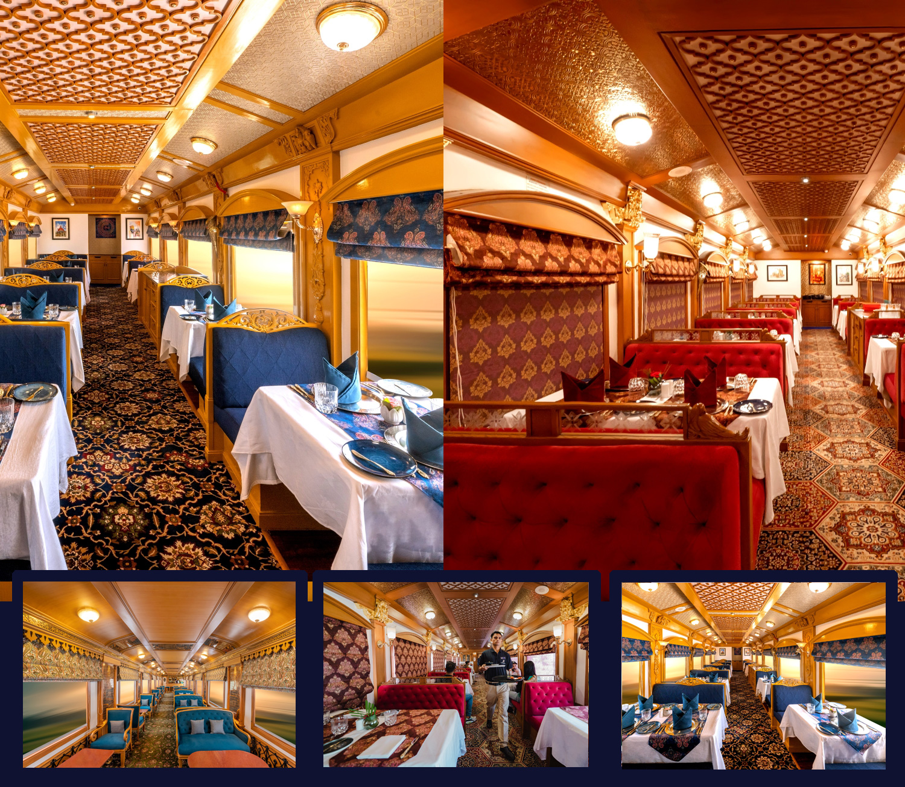
The Deccan Odyssey's two gourmet restaurants, Waavar and Utsav have been designed to keep the element of Indian royalty intact. Our chefs ensure the cuisine keeps pace with the train's journey, by creating local specialties of the every state that the train travels through. So you discover every location with all your senses, including your taste buds! Each meal also includes an International menu to choose from. To further enhance the gourmet experience, Deccan Odyssey presents travelers with a well-stocked bar - Gateway. This is the ideal spot to meet and know your fellow travelers, over an evening drink & snacks.

GATEWAY BAR
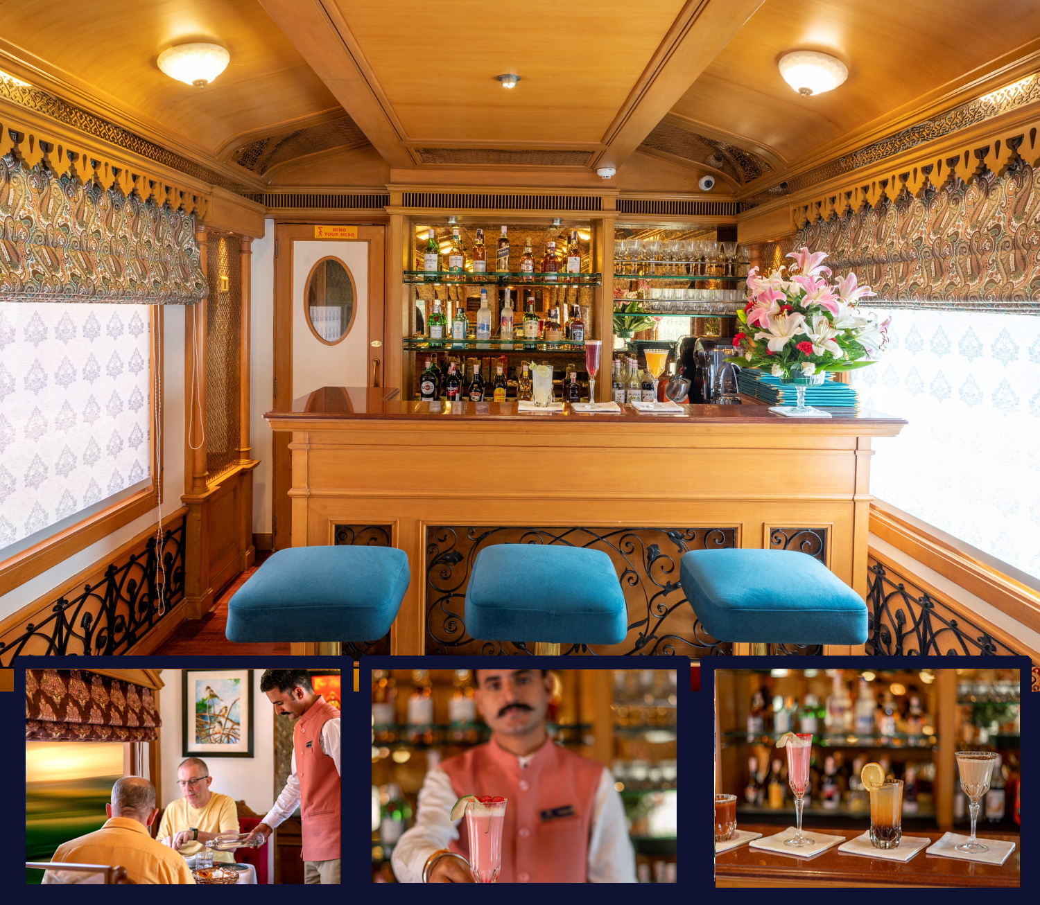
A Well-Stocked Bar with TV Facility serves Wine, Liquor and Spirits of Indian and International make.

CONFERENCE CAR
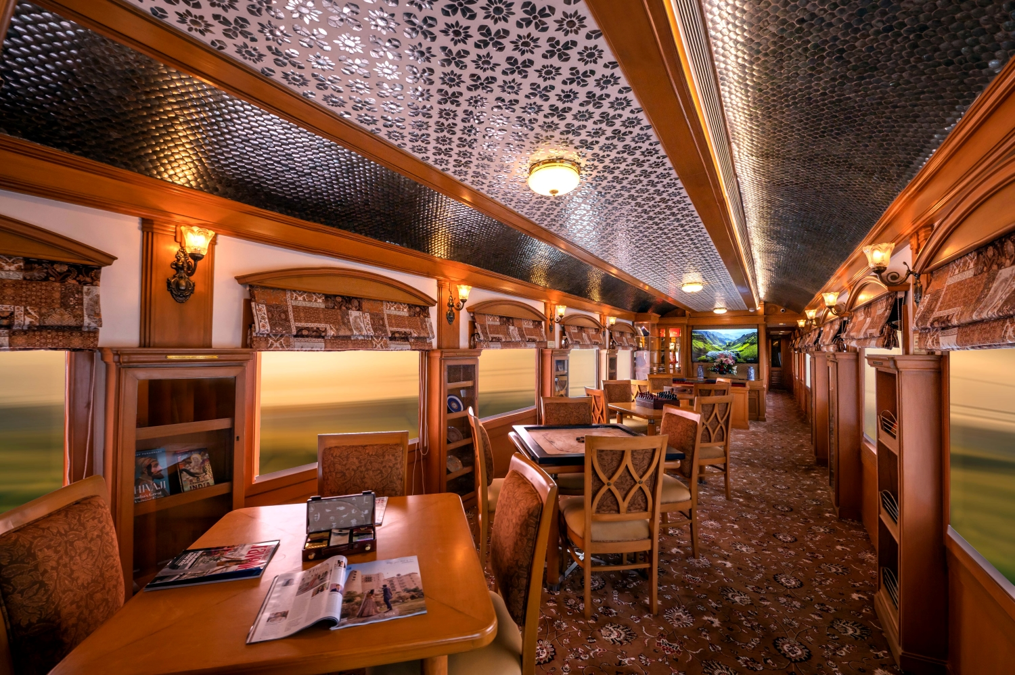
If work requires your time and attention, then our conference car, "Pankh" will take care of all your business needs. Equipped with the latest facilities, it ensures you manage your work efficiently even while you're away travelling.

SPA CAR

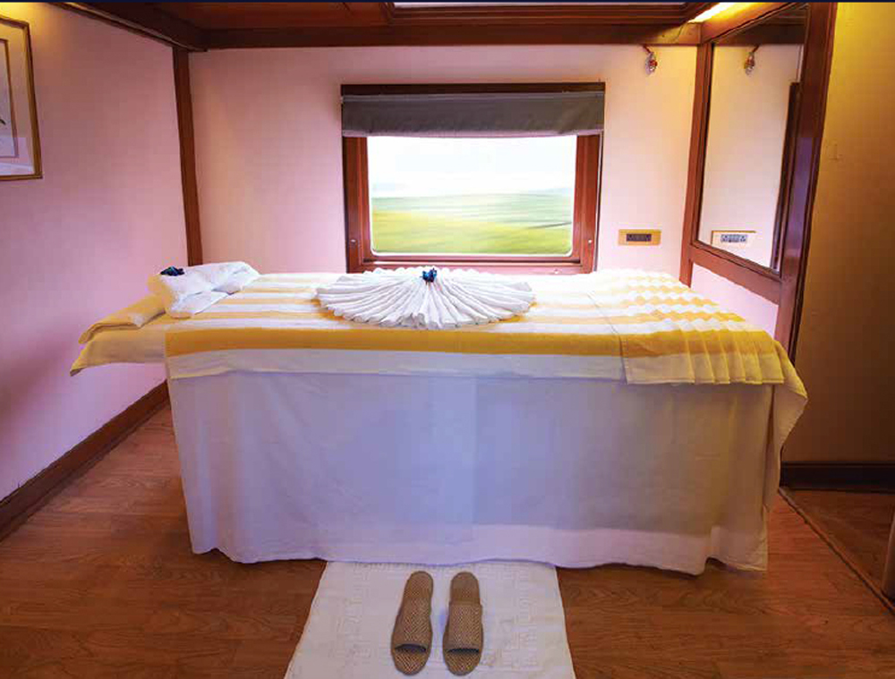

After a long day of exploration, head to Deccan Odyssey's wonderful spa "Ayush". The salon's well-trained masseurs, incorporate ancient Indian techniques to help you relax your body and rejuvenate your mind.

INDIAN SOJOURN ITINERARY

Destinations Covered:

Mumbai l Vishwamitri (Vadodara) l Udaipur l Jodhpur l Jaipur l Agra l Sawai Madhopur l New Delhi

Duration:
07 Nights / 08 Days

INDIAN SOJOURN
Day 1 (Saturday): MUMBAI
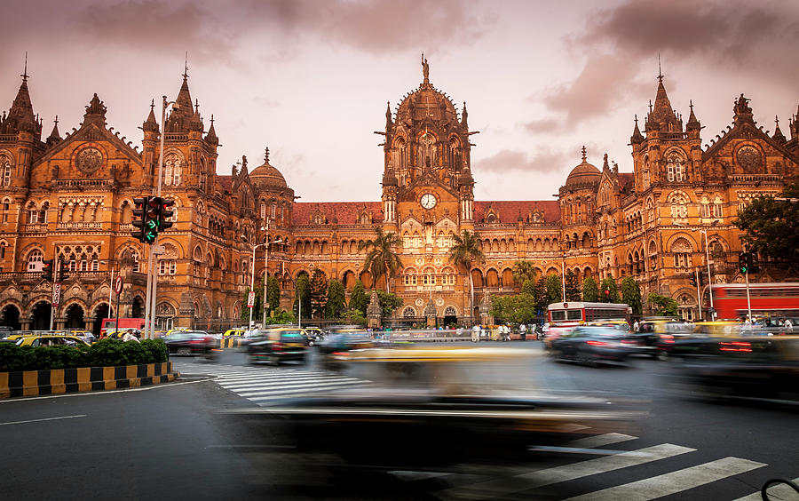
Board the Deccan Odyssey at Mumbai – on to Vadodara

Welcome aboard the Deccan Odyssey.

Early this evening assembles at the Chhatrapati Shivaji Terminus at approximately 1530 hours to complete the registration process and check in formalities for your Indian Sojourn journey, as you receive a traditional Indian welcome and enjoy a refreshing welcome drink.

After completion of all formalities, you will be shown to your delightful cabins. As you settle in, the Deccan Odyssey shall depart Mumbai for Vadodara

Dinner on board

Overnight on Deccan Odyssey

(ETD at 16:40 Hrs)

Day 2 (Sunday): VADODARA
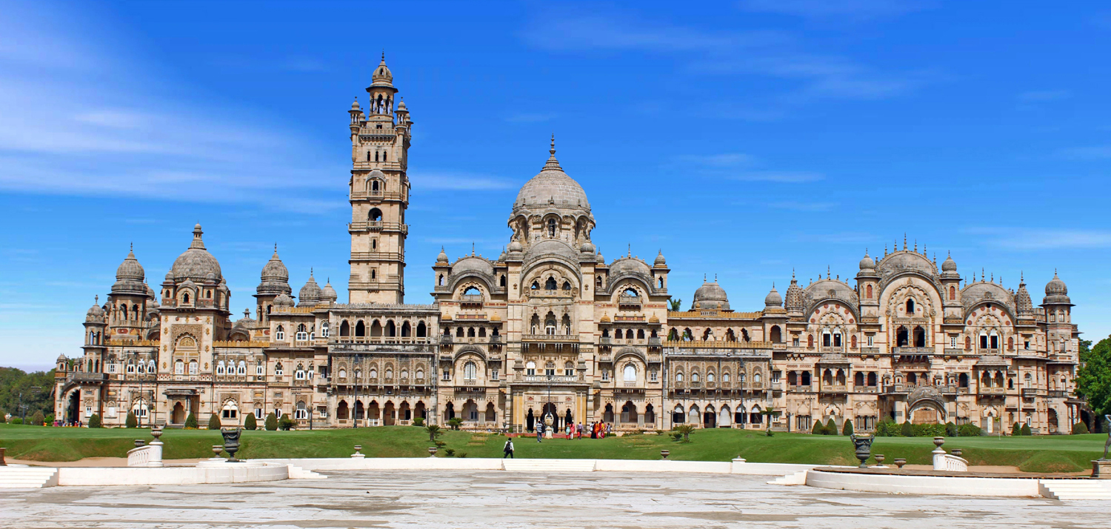
Today you arrive at the capital of the Gaekwads, Vadodara, located along the seasonal river Vishwamitri.

Breakfast on board the Deccan Odyssey.

Post breakfast, you will disembark and proceed to visit Champaner-Pavagadh Archaeological Park, a UNESCO World Heritage site.

Return to Deccan Odyssey for lunch.

Post lunch, drive to the Maharaja Fateh Singh Museum, originally constructed as a school for the Maharaja's children.

Enjoy high tea at the resplendent Laxmi Vilas Palace, built in 1890, and the residence of the Royal family even today.

Return to the Deccan Odyssey for dinner as it pulls out for Udaipur.

Breakfast, Lunch & Dinner on board; High tea at Laxmi Vilas Palace

Overnight on Deccan Odyssey
(ETD at 2000 Hrs)

Day 3 (Monday): UDAIPUR
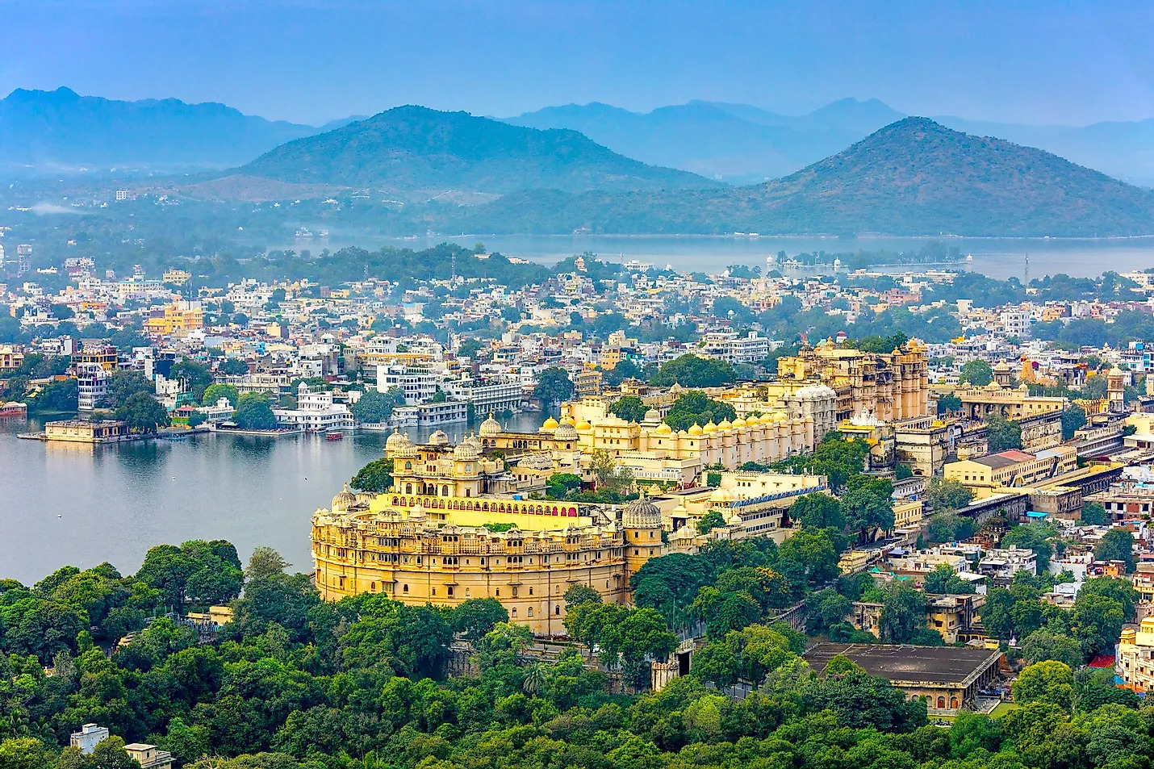
The Deccan Odyssey rolls into Udaipur in the morning. Enjoy your breakfast as you admire the picturesque landscape of the Aravali hills.

You will then disembark to visit the famous City Palace, the largest palace complex in Rajasthan.
Later, board a ferry to ride on Lake Pichola to reach Jagmandir, a 17th century Palace located on an island on the picturesque lake, for an exquisite lunch.

After lunch, later embark on a Walking Tour through the Old City of Udaipur.

Thereafter you return to the Deccan Odyssey for a relaxed evening and dinner as we depart for Jodhpur.

Breakfast on board, Lunch at Jagmandir & Dinner on board

Overnight on Deccan Odyssey
(ETD at 2000 Hrs)

Day 4 (Tuesday): JODHPUR
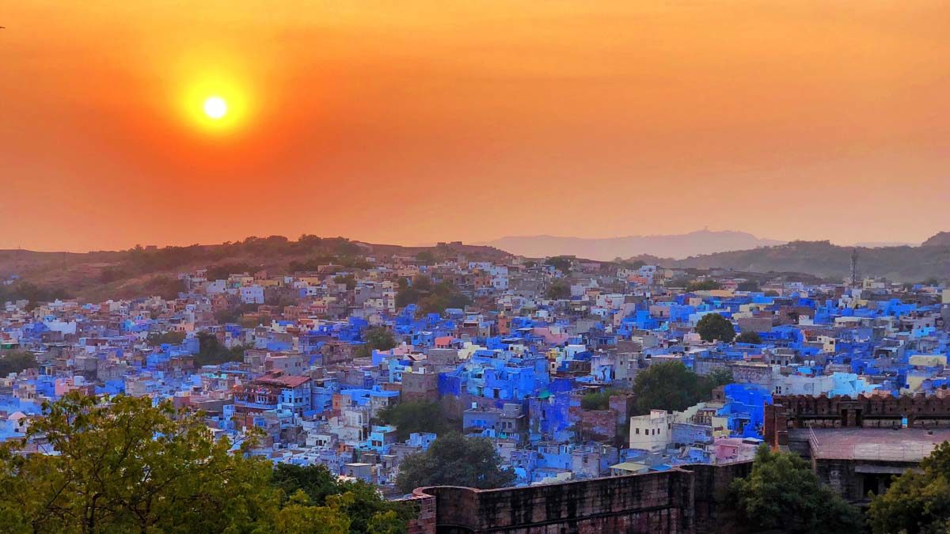
This morning as the Deccan Odyssey travels through the stronghold of the Marwar region, enjoy a relaxing morning on board as you breakfast, unwind and experience the striking panorama of the Thar Desert, arriving at Jodhpur.
The morning is at leisure on board the Deccan Odyssey.
Lunch on board the Deccan Odyssey
Following lunch, set out once again to explore the magnificent city of Jodhpur, also known as the Blue City, after the vivid blue-painted houses that surround the Mehrangarh Fort. Explore city, Walk through the bustle of the Old Clock Tower market, past old havelis and houses, continue to the magnificent Mehrangarh Fort, the pride of Jodhpur.
In the evening enjoy a wide array of sumptuous Marwar barbeque delights served in the royal courtyard of Mehrangarh Fort as you admire the cityscape from atop.
Having taken in your share of the sublime beauty of Jodhpur, return to the Deccan Odyssey and head for Jaipur.
Breakfast & Lunch on board; Barbeque at Mehrangarh Fort.Overnight on Deccan Odyssey
(ETD at 2000 Hrs)

Day 5 (WEDNESDAY): JAIPUR
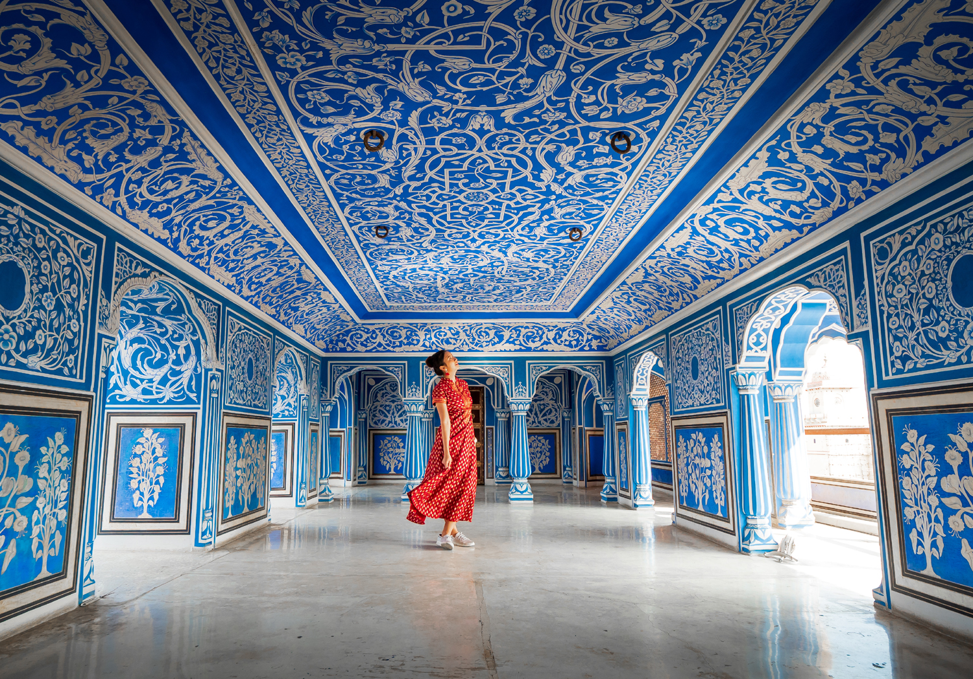
After breakfast you drive to Maharaja Mansingh’s 17th century masterpiece, the Amber Fort that overlooks the beautiful Maota Lake. En-route to Amber Fort visit the Palace of Winds, otherwise known as the Hawa Mahal, famous for its intricate pink sandstone carving and a beautiful view of the city.

Thereafter you will visit the famous City Palace of Jaipur, an overwhelming complex of exquisite palaces, gardens and courtyards, decorative art and carved doorways.

Lunch at a City hotel. Following lunch, you may choose to participate in shopping experience.
After your full day of delving in the royal past of Jaipur you will return to the Deccan Odyssey for dinner on board as it departs for Agra.

Breakfast on board; Lunch at a City hotel; Dinner on board

Overnight on Deccan Odyssey
(ETD at 2000 Hrs)

Day 6 (Thursday): AGRA
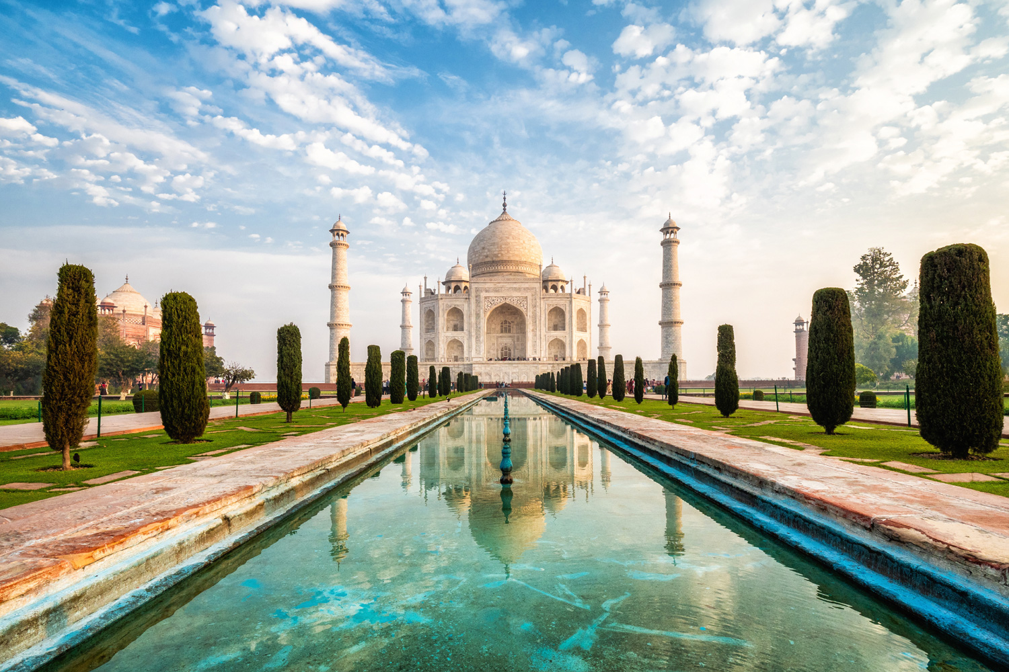
Arriving at Agra.
Lunch at a City Hotel.

Afternoon visit to Agra Fort, A visit to the Diwan-e-Am, ‘Hall of Public Audience’ and the Royal Pavilions is not to be missed.

Later, you have the opportunity to visit the local showroom to admire the exquisite Pietra Dura (marble inlay) artefacts and Mughal ornaments.

Late evening, you return to the Deccan Odyssey for dinner and your onward journey to Sawai Madhopur.

Breakfast on board; Lunch at a City Hotel; Dinner on board

Overnight on Deccan Odyssey
(ETD at 2000 Hrs)

Day 7 (FRIDAY): SAWAI MADHOPUR
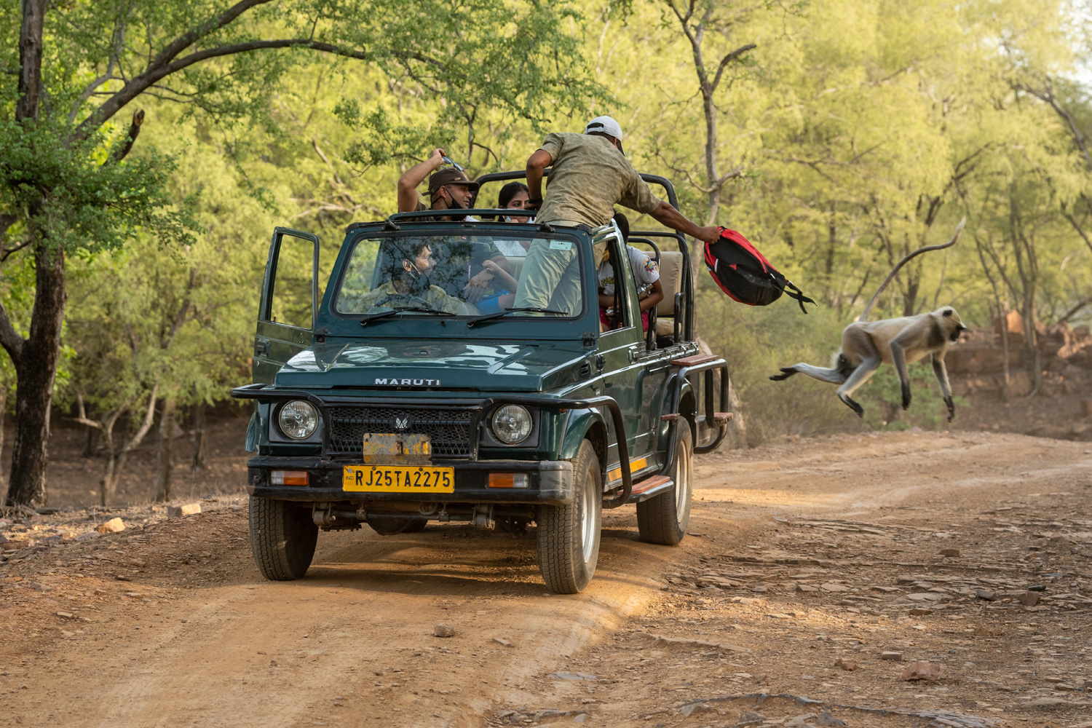
Sawai Madhopur, in Rajasthan is the alighting point for the famous Ranthambore National Park, and India’s efforts to conserve the dwindling tiger population can be seen here.

Enjoy breakfast before your morning village safari. Visit a local home for a and interact with the family. Post the village tour head back to the comfort of Deccan Odyssey for asumptuous lunch.

Post lunch, disembark to head for the afternoon safari.

After a fulfilling afternoon, proceed for high tea at the Sawai Madhopur Lodge, feel free to share the spoils (of your photo-shoots!) over a leisurely hi tea.

After high tea, it is time to head back to the Deccan Odyssey where you can relax with a drink before dinner on board, as the Deccan Odyssey sets off for Delhi.

Breakfast, Lunch & Dinner on board; High tea at Taj Sawai Madhopur Lodge
Overnight on Deccan Odyssey
(Departure at 19:30)

Day 8 (Saturday): DELHI
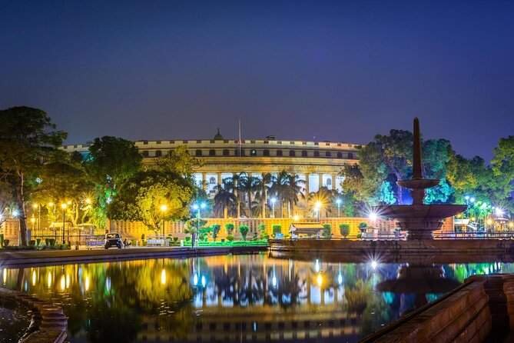
Disembark in Delhi

Early this morning, after breakfast, you will disembark at the Delhi Safdarjung Station.
Bid farewell to the Deccan Odyssey as your royal passage through the grand vistas of India comes to an end.
Breakfast on board

DEPARTURE DATES
2023 | 2024 | 2025 | 2026
23 September  18 November  23 December | 13 January  17 February  16 March  6 April  28 September  26 October  16 November  21 December | 18 January  1, 29 March  12 April  27 September  25 October  15 November  20 December | 21 February  28 March  11 April

TARIFF 2023 –2024 (Per Cabin Per Journey)
Category | Single Occupancy | Double Occupancy | 02 Children  (in a separate deluxe cabin)
Deluxe Cabin | $8,330 | $11,900 | Price on Request
Presidential Suite | $17,850 | $17,850 | Price on Request

TARIFF 2024-2025 (Per Cabin Per Journey)
Category | Single Occupancy | Double Occupancy | 02 Children  (in a separate deluxe cabin)
Deluxe Cabin | $8,330 | $11,900 | Price on Request
Presidential Suite | $17,850 | $17,850 | Price on Request

TARIFF 2025-2026 (Per Cabin Per Journey)
Category | Single Occupancy | Double Occupancy | 02 Children  (in a separate deluxe cabin)
Deluxe Cabin | $9,330 | $13,300 | Price on Request
Presidential Suite | $20,000 | $20,000 | Price on Request

Inclusions | Exclusions
- Accommodation in double / twin bedded cabin with en suite bathrooms  - All meals (B, L, D)  - Soft beverages during the journey  - Valet service  - Still camera fees  - Guided oﬀ train excursions and game drives as illustrated in the itinerary – inclusive of entrance fees, park fees, transport and services of an English-speaking local guide | - Taxes including 5.00% (subject to change as per Govt. directives)  - Government Service tax, Insurance, gratuities  - Laundry and alcoholic Beverages  - Video and professional Still camera fees  - Arrival and Departure transfers  - International and Domestic air tickets  - Pre and Post tour accommodation and any tour extensions unless specifically mentioned as a part of the journey  - All activities mentioned as ‘options’ in the itinerary.
Booking Policy
20% of the tariff: at the time of the confirmation of the booking.
Remaining 80% of the tariff: to be paid 60 days prior to departure
Cancellation Policy
Retention of 10% of ticket value: cancelling 60 days prior to the departure date.
Retention of 20% of ticket value: cancelling 59 – 45 days prior to the departure date
Retention of 50% of ticket value: cancelling 44 – 30 days prior to the departure date
Retention of 100% of ticket value: cancelling 29 – 45 days prior to the departure date
Terms and Conditions
- All Costs are in USD
- The above costs are per cabin per Journey
- As the train runs on the tracks of the Indian Railways, the itineraries are subject to change in case of any changes in the routing
- Prices are subject to change in case of any amendment in the routing or other hikes such as fuel, taxes
- Children below 5 years of age shall be allowed free, subject to sharing of double bed with This is subject to availability of double bed at the time of booking
- Presidential Suite can accommodate up to 3 adults or 2 Adults and 2 children (One child up to 5 years of age and second child up to 12 years of age)
- Government Service tax of 5.00% (subject to change as per Govt. directives) is additional and will be charged extra on the published tariﬀ.
- All Departures and Arrivals are on Tentative basis and are subject to approval from Indian Railways.
- The Entire Deccan Odyssey Train is non-Smoking. For any particular requirement, kindly contact your Valet.
- We need minimum occupancy to operate all listed journeys, in event if we do not manage minimum occupancy we reserve the right to cancel the journey at least with 30 days prior intimation.
- Paramedic on Board
