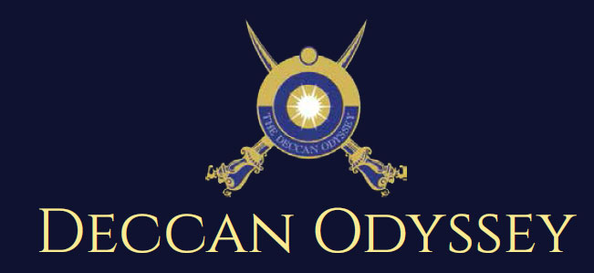

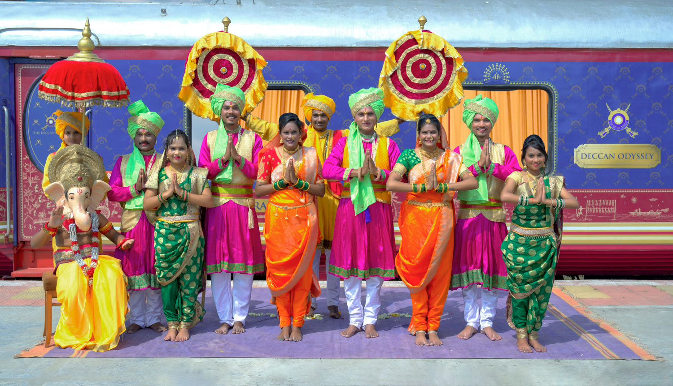

There's something unique about trains. They make you nostalgic. They transport us to far off places and we every day wake up to a new land of mystic and wonders. Trains are home to countless stories.

"Mickey Mouse popped out of my mind onto a drawing pad 20 years ago on a train ride from Manhattan to Hollywood at a time when business fortunes of my brother Roy and myself were at lowest ebb and disaster seemed right around the corner".

Walt Disney

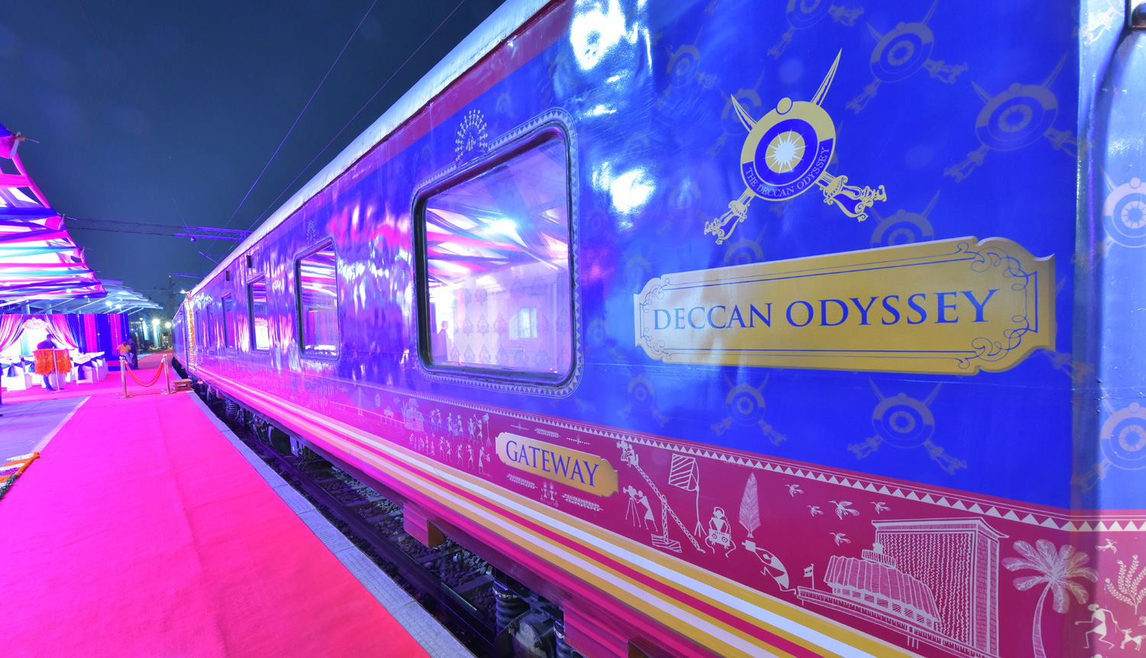

A journey that remains, magical and memorable. The Deccan Odyssey Train Routes and journeys designed to discover the art, architecture, culture, history and wildlife in style. Choose from set of excellent journeys that take you through different parts of India.

TRAIN LAYOUT
Passenger Cars (4 Coupes per Coach) (10)
Presidential Suite Cars (2 Coupes per Coach) (02)
Conference Car with Business Centre (01)
Restaurant Cars (02)
Staff, spare car (02)
Spa Car (01)
Bar Car (01)
Generator Cars with Luggage Store (02)
Total Coaches- 21 -
It can accommodate 88 guests at a time

PRESIDENTIAL SUITE

Dimensions  Cabin Area: 191 Sq Ft  Cabin Length: 8.4 meter  Cabin Width: 2.3 meter  Bed Length: 2.0 meter  Bed Width:0.9 meter  Cabin per Coach: 2 | Private attached bathroom with shower; channel music facility; Individual temperature control panel; direct dial telephone; electronic safe & small cupboard; Presidential suite cabins have a master bedroom with spacious living area, two bathrooms, Personal butler available in each sleeper carriage 24hrs.

DELUXE CABIN

Dimensions  Cabin Area: 95 Sq Ft  Cabin Length: 3.97 meter  Cabin Width: 2.3 meter  Bed Length: 2.0 meter  Bed Width:0.9 meter  Cabin per Coach: 4 | Deluxe Coach features 4 Double/ Twin bed cabins. Direct dial phone, electronic safe, and individual climate control facility. Bathrooms come fitted with wash basin & shower, shower cubicle and running hot and cold water; Twin bed is 6' x 3'. Specially equipped cabin, for the comfort of our diﬀerently-abled guests.

RESTAURANTS

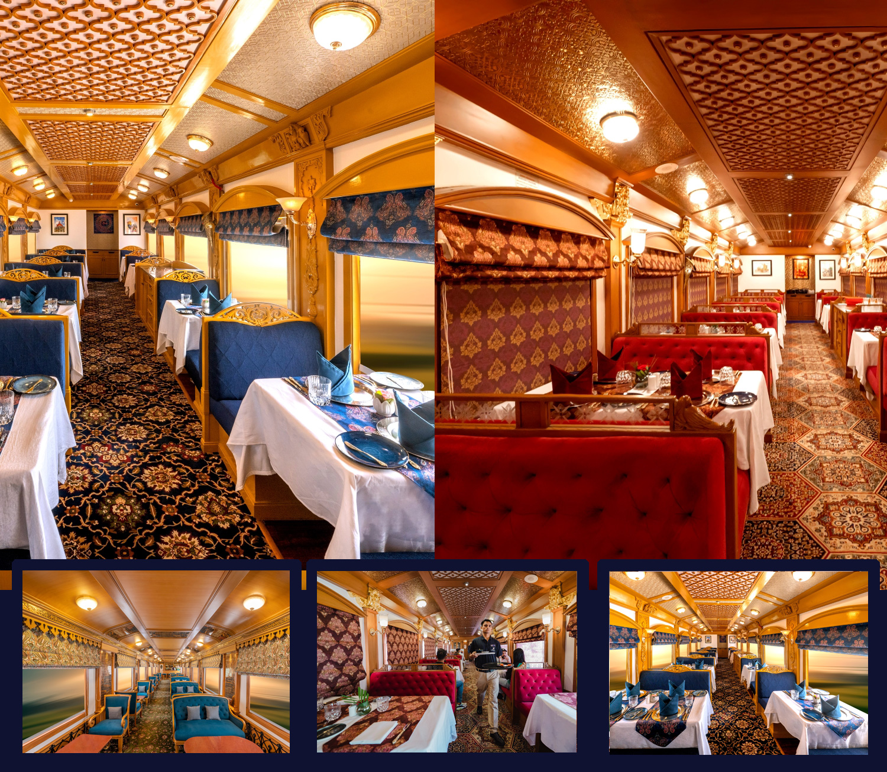
The Deccan Odyssey's two gourmet restaurants, Waavar and Utsav have been designed to keep the element of Indian royalty intact. Our chefs ensure the cuisine keeps pace with the train's journey, by creating local specialties of the every state that the train travels through. So you discover every location with all your senses, including your taste buds! Each meal also includes an International menu to choose from. To further enhance the gourmet experience, Deccan Odyssey presents travelers with a well-stocked bar - Gateway. This is the ideal spot to meet and know your fellow travelers, over an evening drink & snacks.

GATEWAY BAR
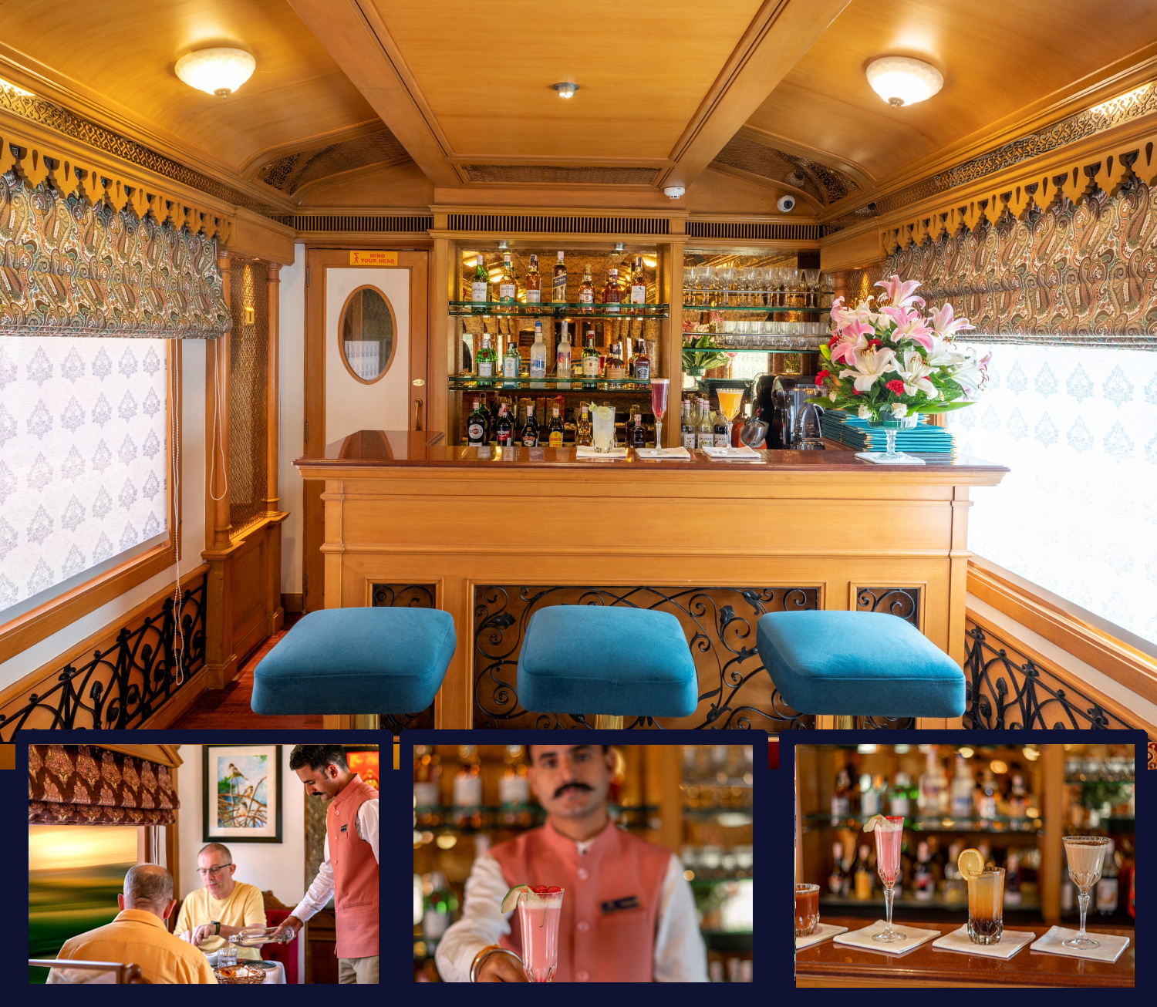
A Well-Stocked Bar with TV Facility serves Wine, Liquor and Spirits of Indian and International make.

CONFERENCE CAR
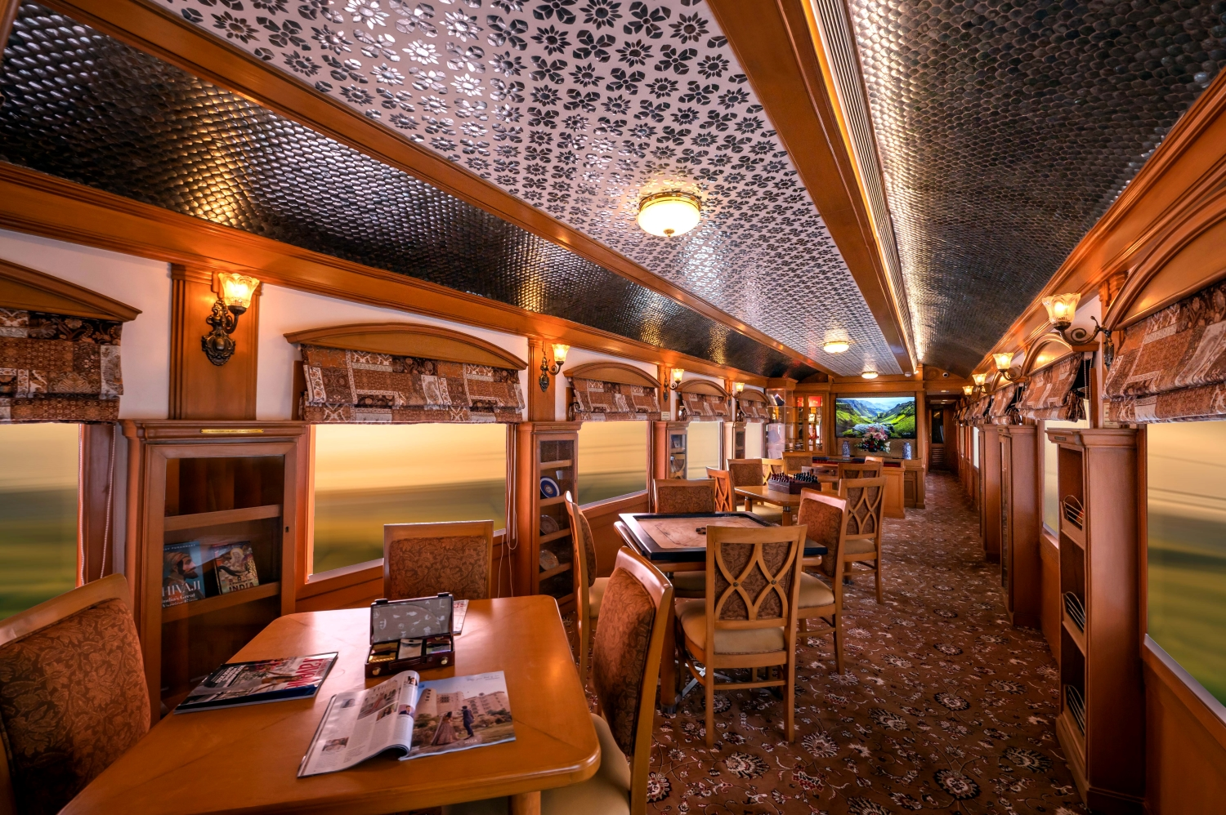
If work requires your time and attention, then our conference car, "Pankh" will take care of all your business needs. Equipped with the latest facilities, it ensures you manage your work efficiently even while you're away travelling.

SPA CAR

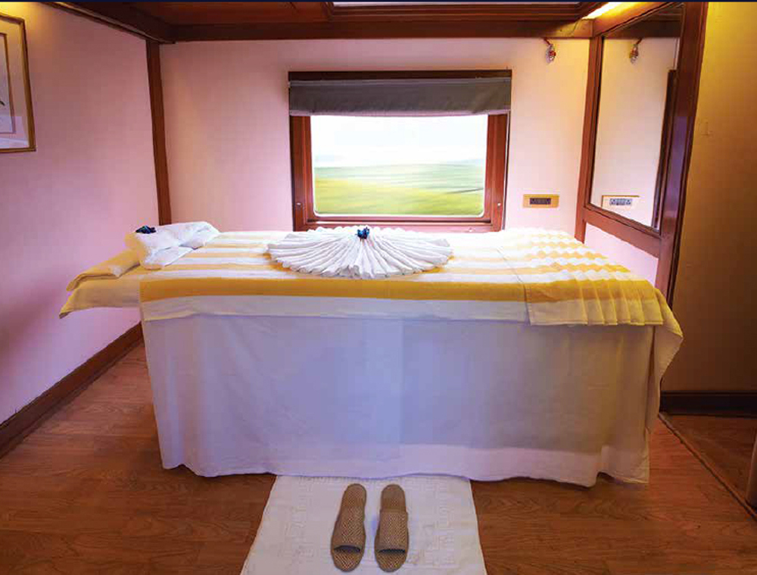

After a long day of exploration, head to Deccan Odyssey's wonderful spa "Ayush". The salon's well-trained masseurs, incorporate ancient Indian techniques to help you relax your body and rejuvenate your mind.

INDIAN ODYSSEY ITINERARY

Destinations Covered:

New Delhi | Agra | Sawai Madhopur | Jaipur | Udaipur | Vadodara | Ellora Caves | Mumbai

Duration:
07 Nights / 08 Days

INDIAN ODYSSEY
Day 1 (Saturday): DELHI
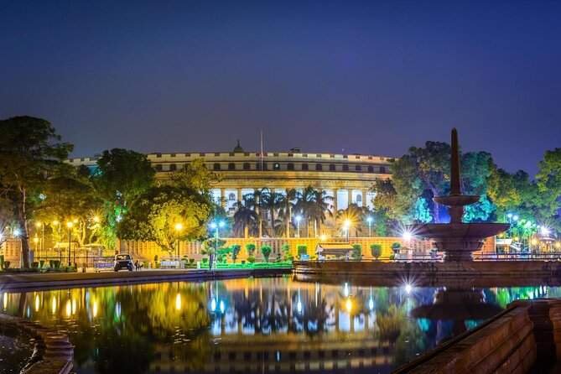
- Board the Deccan Odyssey at Delhi – on to Agra

Welcome aboard the Deccan Odyssey.

This evening assemble at the railway station at approximately 1700 hours to complete the registration process and check in formalities for your Indian Odyssey journey, as you receive a traditional Indian welcome and enjoy a refreshing welcome drink.

After completion of all formalities, you will be shown to your delightful cabins. As you settle in, the Deccan Odyssey shall depart Delhi for Agra.

Dinner on board

Overnight on Deccan Odyssey
(ETD at 1930 Hrs)
(ETD at 1800 Hrs)

Day 2 (Sunday): AGRA
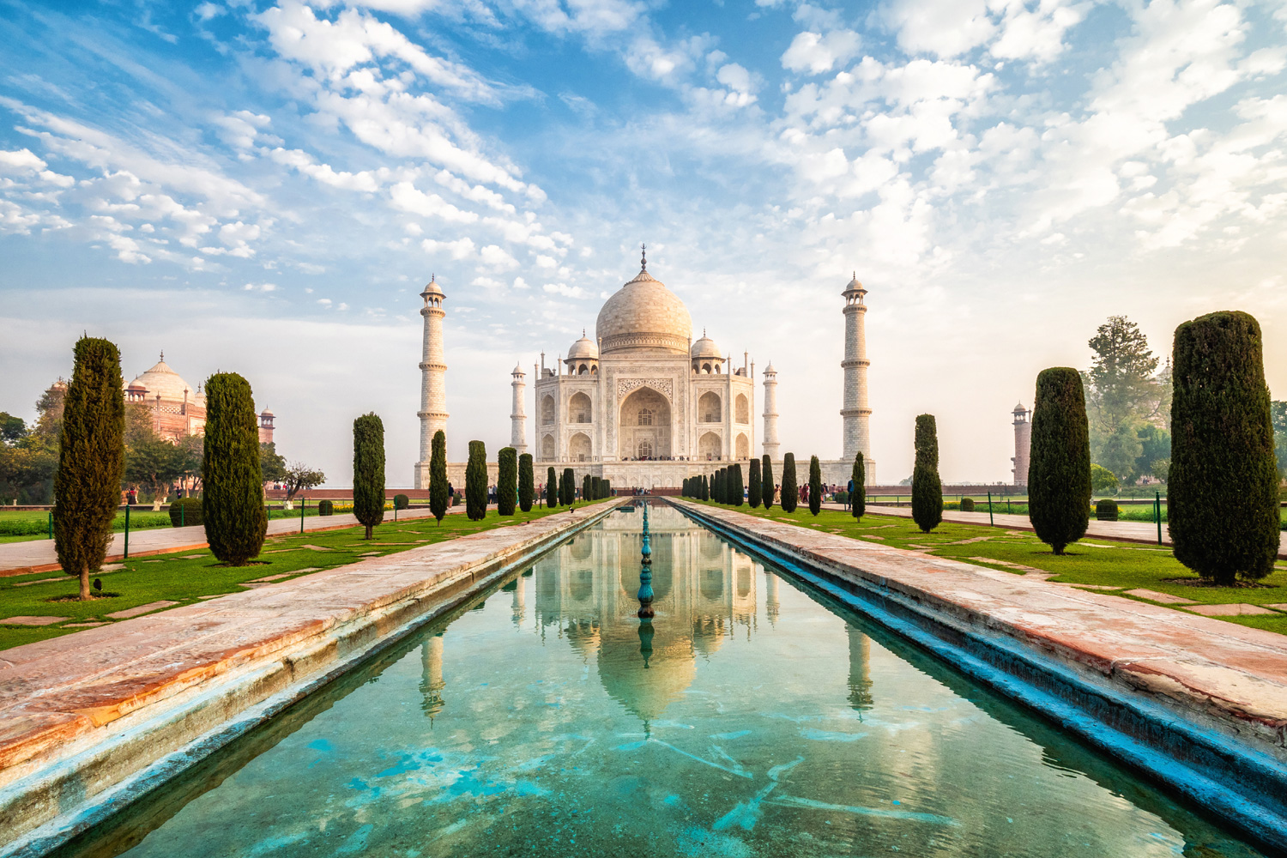
Arriving at Agra.

0830 Hrs: Deboard Deccan Odyssey and drive to Agra from Tundla Railway Station
0930 Hrs: You will visit the Taj Mahal, which was Emperor Shah Jahan’s gift of love to his beloved wife, Mumtaz Mahal, and is truly the world’s most wondrous monument.

1300 Hrs: Lunch at City Hotel.
1400 Hrs: Proceed for Agra Fort another outstanding example of Mughal architecture, and the seat of Mughal reign and administration for three generations. A visit to the Diwan-e-Am, ‘Hall of Public Audience’ and the Royal Pavilions is not to be missed.

1630 Hrs: Visit Kalakriti to witness the art of Inlay Work which can be found in Mughal structures. The Technique is known as Pietra Dura which have beautified Taj Mahal.
1900 Hrs: Return to the Deccan Odyssey for dinner and your onward journey to Sawai Madhopur.
Breakfast on board | Lunch at a City Hotel | Dinner on board
Overnight on Deccan Odyssey
(Departure at 20:00)
Day 3 (Monday): SAWAI MADHOPUR
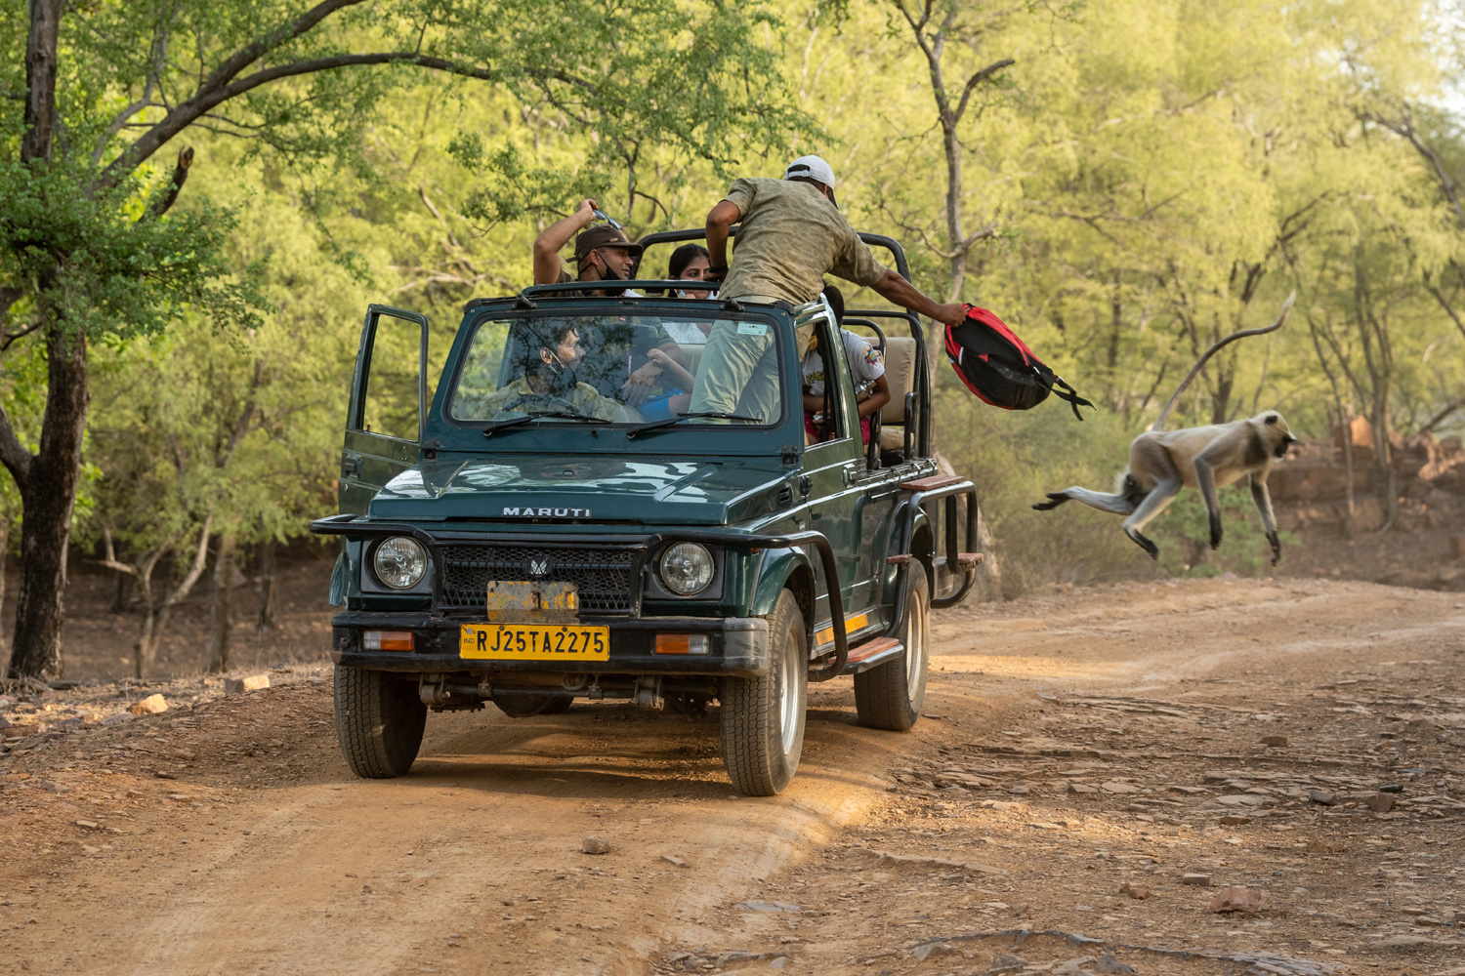
Sawai Madhopur, in Rajasthan is the alighting point for the famous Ranthambore National Park, and India’s efforts to conserve the dwindling tiger population can be seen here.

Enjoy Breakfast On Board Decan Odyssey

0830 Hrs: proceed for Ranthambore Village visit

1230 Hrs: Return to Deccan Odyssey for Lunch
1430 Hrs: Disembark to head for the afternoon safari.
1715 Hrs: Head back to the Deccan Odyssey where you can relax with a drink before dinner on board, as the Deccan Odyssey sets off for Jaipur.
Breakfast, Lunch and Dinner on board
Overnight on Deccan Odyssey
(Departure at 18:30)

Day 4 (Tuesday): JAIPUR
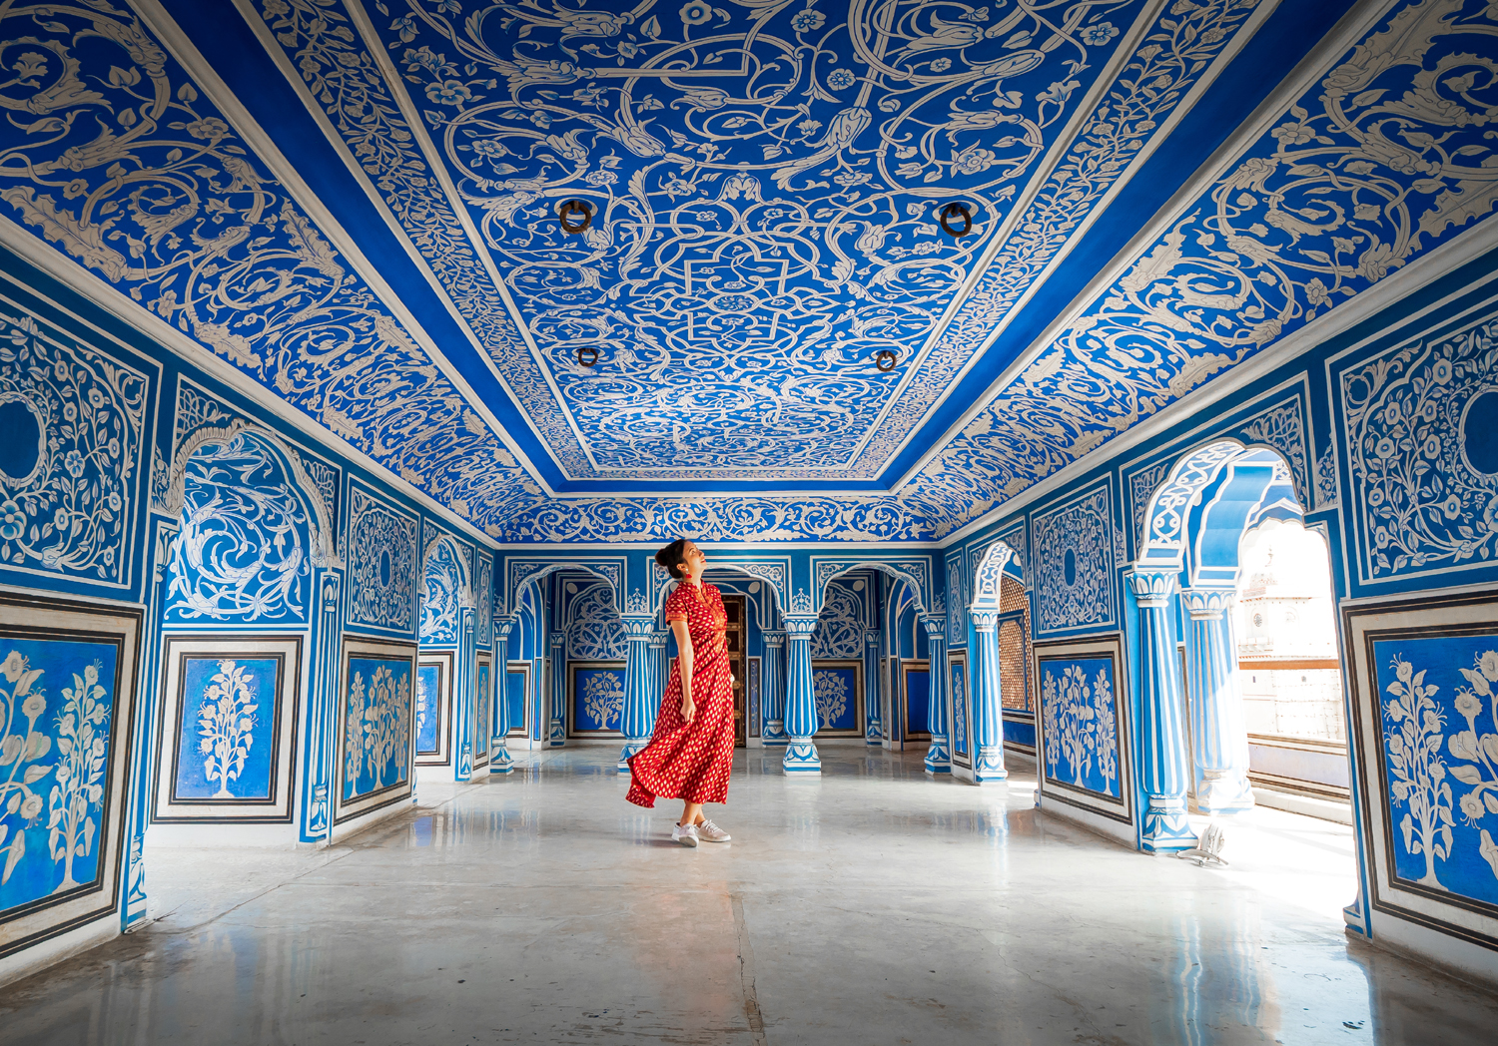
Legendary for the triumphs of its proud Rajputs, Jaipur, the City of Victory, is surrounded by the rugged Aravali hills - crowned by formidable forts - and beautiful palaces, mansions and gardens. Royal processions and parades, in all their splendour, graced these palaces and forts once.
0830 Hrs: Disembark from Station ( Welcome at the station)
0900 Hrs: Leave station for Amber Fort
1030 Hrs : Visit of Amber Fort
1300 Hrs: Lunch at City Hotel
1530 Hrs: Visit of City Palace
1900 Hrs: Leave city Palace for Station
Breakfast on board | Lunch at City Hotel | Dinner on board
Overnight on Deccan Odyssey
(Departure at 20:00)

Day 5 (WEDNESDAY): UDAIPUR
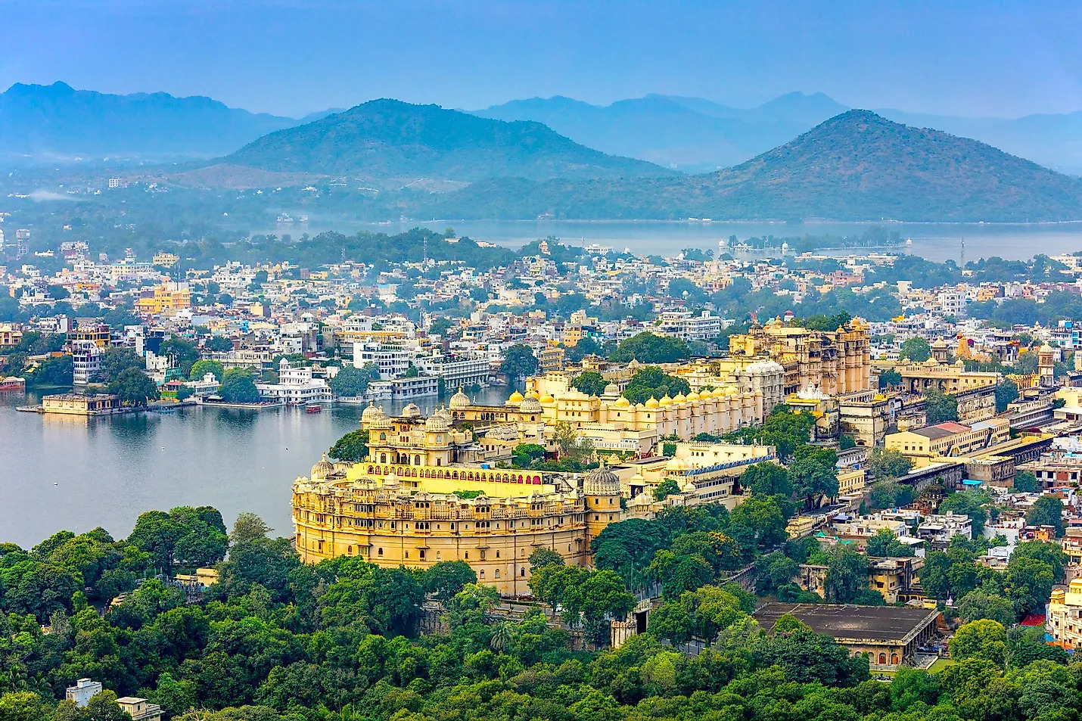
The Deccan Odyssey rolls into Udaipur in the morning. Enjoy your breakfast as you admire the picturesque landscape of the Aravali hills.

1000 Hrs: Disembark to visit the famous City Palace, the largest palace complex in Rajasthan, with its
scalloped arches, fretted balconies, and cupolas, which also houses the spectacular Crystal Gallery.
The tour of this magnificent city is completed with a boat cruise on the tranquil waters of Lake Pichola.

1330 Hrs: Lunch at City Hotel

1430 hrs : Proceed on a walking tour through the Old City of Udaipur and explore the Old City’s lively, busy and old-fashioned colourful bazar which still retains local charm and feel.
1800 hrs : Return to the Deccan Odyssey for a relaxed evening and dinner.
Breakfast on board | Lunch at a City Hotel | Dinner on board
Overnight on Deccan Odyssey
(Departure at 20:00)

Day 6 (Thursday): VADODARA
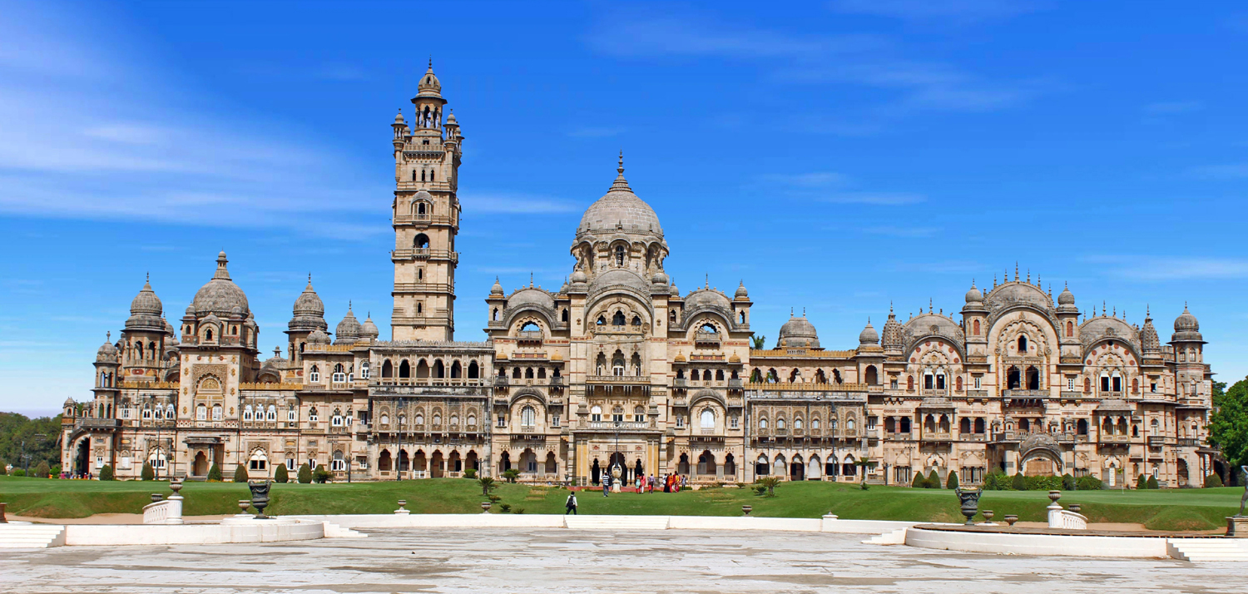
Today you arrive at the capital of the Gaekwads, Vadodara, located along the seasonal river Vishwamitri.
Breakfast on board the Deccan Odyssey.
0830 Hrs: After breakfast, you will disembark and proceed to visit Champaner-
1000 Hrs: Reach Champaner and visit Pavagadh Archaeological Park, a UNESCO World Heritage site.
1200 Hrs: Leave for Vadodara
1330 Hrs: Reach Deccan Odyssey and Lunch on Board
1530 Hrs: Visit the Maharaja Fateh Singh Museum.
1730 Hrs: Enjoy Snacks & tea at the resplendent Laxmi Vilas Palace. Witness a folk performance typical of the region as you savour some of the special delicacies from the Royal kitchens.
1900 Hrs: Return to the Deccan Odyssey as it heads for Aurangabad.
Breakfast, Lunch & Dinner on board | Tea & Snacks at Laxmi Vilas Palace
Overnight on Deccan Odyssey
(Departure at 20:00)

Day 7 (FRIDAY): ELLORA CAVES
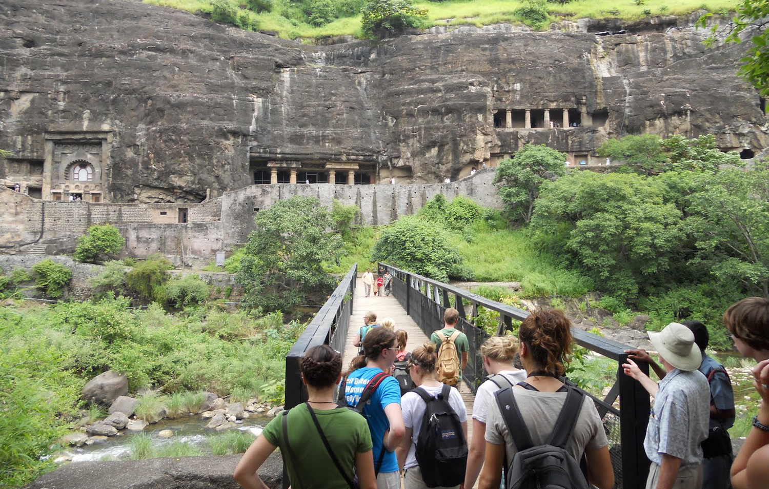
Breakfast & Lunch on Board
1230 Hrs: Lunch on Board
1330 Hrs: Disembark from the Train
1500 Hrs: Leave for Ellora Caves

1800 Hrs: Return to Deccan Odyssey.
Today brings a late start, leaving the morning free for you to enjoy a languid breakfast and enjoy some of the activities available on board. Later, as you savour lunch, the Deccan Odyssey arrives at Aurangabad, from where a scenic drive takes you to the Ellora Caves.
After exploring Ellora, return to the Deccan Odyssey.

Breakfast, Lunch & Dinner on board
Overnight on Deccan Odyssey
(Departure at 19:00)
Day 8 (Saturday): MUMBAI
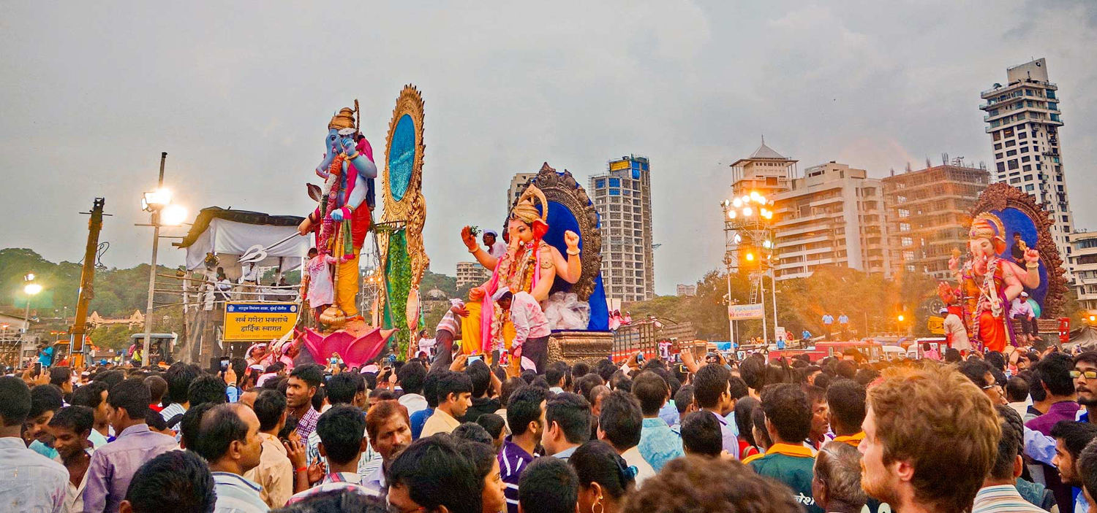
Disembark in Mumbai

Early this morning, after breakfast, you will disembark at Chhatrapati Shivaji Terminus Railway Station, Mumbai.

Bid farewell to the Deccan Odyssey as your royal passage through the grand vistas of India comes to an end.

Breakfast on board

DEPARTURE DATES
2023 | 2024 | 2025 | 2026
30 September  02 December | 06 January  27 January  09 March  06 April  05 October  02 November  07 December | 11 January  25 January  15 March  05 April  26 April  04 October  01 November  06 December | 14 March  04 April

TARIFF 2023 –2024 (Per Cabin Per Journey)
Category | Single Occupancy | Double Occupancy | 02 Children  (in a separate deluxe cabin)
Deluxe Cabin | $8,330 | $11,900 | Price on Request
Presidential Suite | $17,850 | $17,850 | Price on Request

TARIFF 2024-2025 (Per Cabin Per Journey)
Category | Single Occupancy | Double Occupancy | 02 Children  (in a separate deluxe cabin)
Deluxe Cabin | $8,330 | $11,900 | Price on Request
Presidential Suite | $17,850 | $17,850 | Price on Request

TARIFF 2025-2026 (Per Cabin Per Journey)
Category | Single Occupancy | Double Occupancy | 02 Children  (in a separate deluxe cabin)
Deluxe Cabin | $9,330 | $13,300 | Price on Request
Presidential Suite | $20,000 | $20,000 | Price on Request

Inclusions | Exclusions
- Accommodation in double / twin bedded cabin with en suite bathrooms  - All meals (B, L, D)  - Soft beverages during the journey  - Valet service  - Still camera fees  - Guided oﬀ train excursions and game drives as illustrated in the itinerary – inclusive of entrance fees, park fees, transport and services of an English-speaking local guide | - Taxes including 5.00% (subject to change as per Govt. directives)  - Government Service tax, Insurance, gratuities  - Laundry and alcoholic Beverages  - Video and professional Still camera fees  - Arrival and Departure transfers  - International and Domestic air tickets  - Pre and Post tour accommodation and any tour extensions unless specifically mentioned as a part of the journey  - All activities mentioned as ‘options’ in the itinerary.
Booking Policy
20% of the tariff: at the time of the confirmation of the booking.
Remaining 80% of the tariff: to be paid 60 days prior to departure
Cancellation Policy
Retention of 10% of ticket value: cancelling 60 days prior to the departure date.
Retention of 20% of ticket value: cancelling 59 – 45 days prior to the departure date
Retention of 50% of ticket value: cancelling 44 – 30 days prior to the departure date
Retention of 100% of ticket value: cancelling 29 – 45 days prior to the departure date
Terms and Conditions
- All Costs are in USD
- The above costs are per cabin per Journey
- As the train runs on the tracks of the Indian Railways, the itineraries are subject to change in case of any changes in the routing
- Prices are subject to change in case of any amendment in the routing or other hikes such as fuel, taxes
- Children below 5 years of age shall be allowed free, subject to sharing of double bed with This is subject to availability of double bed at the time of booking
- Presidential Suite can accommodate up to 3 adults or 2 Adults and 2 children (One child up to 5 years of age and second child up to 12 years of age)
- Government Service tax of 5.00% (subject to change as per Govt. directives) is additional and will be charged extra on the published tariﬀ.
- All Departures and Arrivals are on Tentative basis and are subject to approval from Indian Railways.
- The Entire Deccan Odyssey Train is non Smoking. For any particular requirement, kindly contact your Valet.
- We need minimum occupancy to operate all listed journeys, in event if we do not manage minimum occupancy we reserve the right to cancel the journey at least with 30 days prior intimation.
- As Train runs on tracks so you may experience sounds of passing trains and some shaking during the journey. This is a normal feature countrywide with trains in India.
- Paramedic on Board
