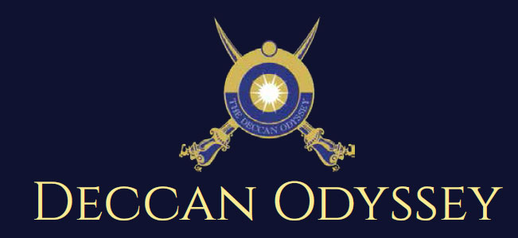
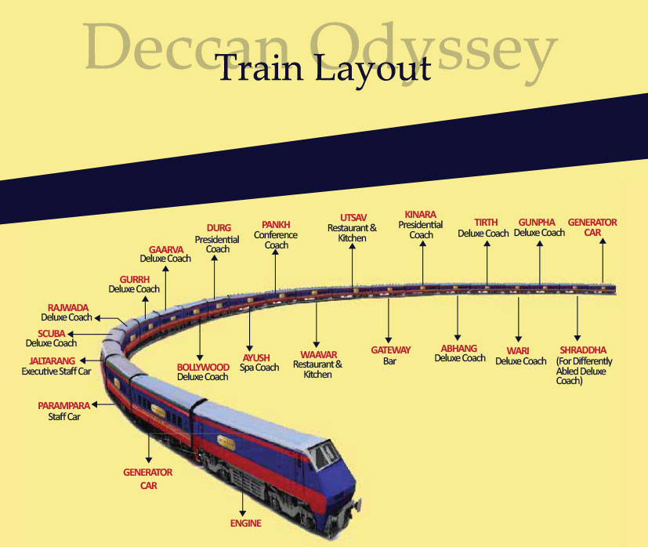
Passenger Cars (4 Coupes per Coach) (10)
Presidential Suite Cars (2 Coupes per Coach) (02)
Conference Car with Business Centre (01)
Restaurant Cars (02)
Staff, spare car (02)
Spa Car (01)
Bar Car (01)
Generator Cars with Luggage Store (02)

Total Coaches- 21 - It can accommodate 88 guests at a time

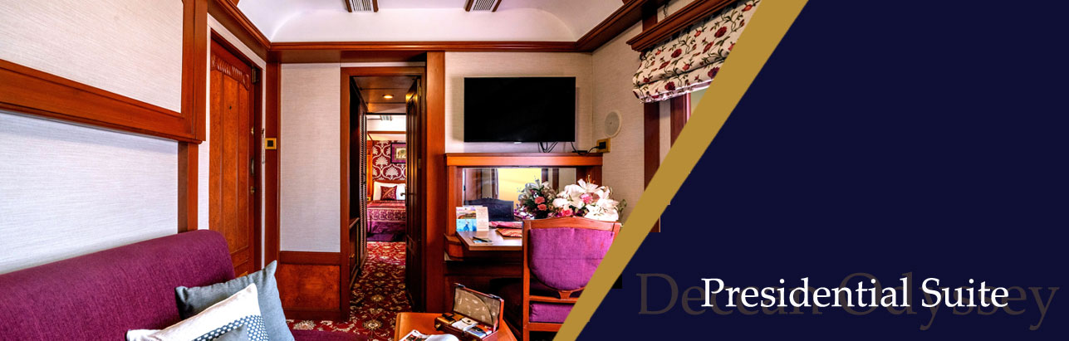
Private attached bathroom with shower; channel music facility; Individual temperature control panel; direct dial telephone; electronic safe & small cupboard; Presidential suite cabins have a master bedroom with spacious living area, two bathrooms, Personal butler available in each sleeper carriage 24hrs.

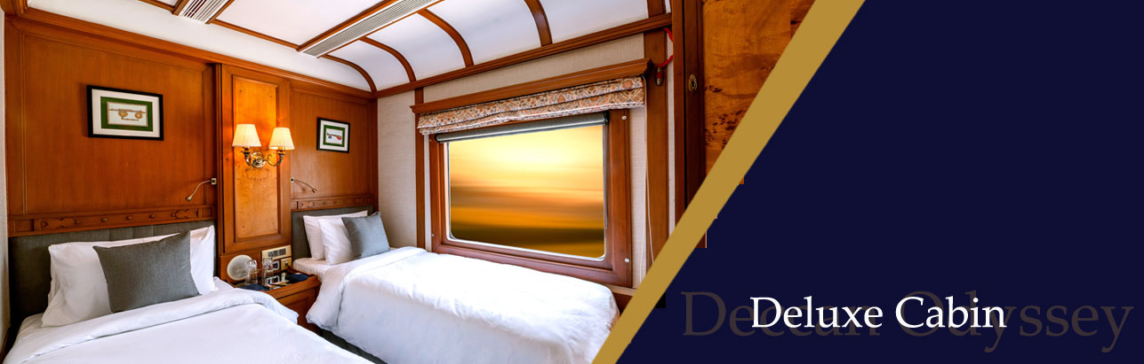
Every Deluxe Coach features 4 Double/ Twin bed cabins. Direct dial phone, electronic safe, and individual climate control facility. Bathrooms come fitted with wash basin & shower, shower cubicle and running hot and cold water; Twin bed is 6' x 3'. Specially equipped cabin, for the comfort of our diﬀerently-abled guests.

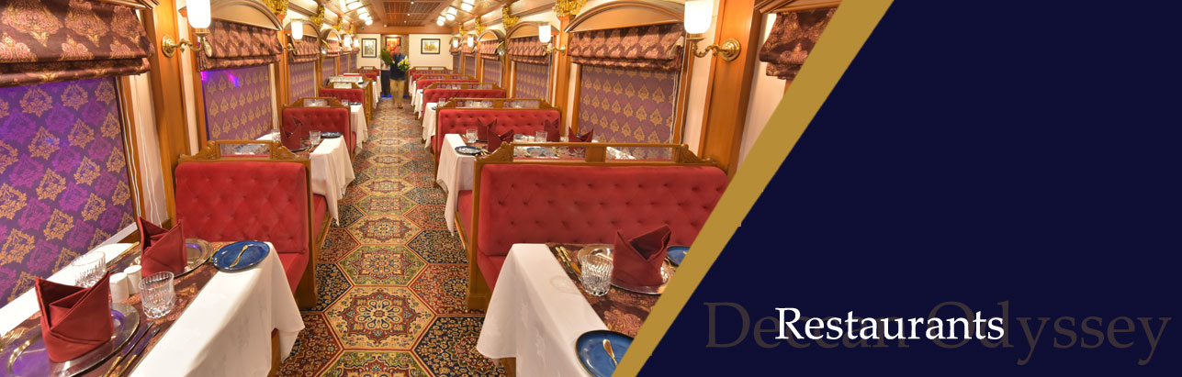
The Deccan Odyssey's two gourmet restaurants, Waavar and Utsav have been designed to keep the element of Indian royalty intact. Our chefs ensure the cuisine keeps pace with the train's journey, by creating local specialties of the very state that the train travels through. So you discover every location with all your senses, including your taste buds! Each meal also includes an International menu to choose from. In order to further enhance the gourmet experience, Deccan Odyssey presents travelers with a well-stocked bar - Gateway. This is the ideal spot to meet and know your fellow travellers, over an evening drink & snacks.
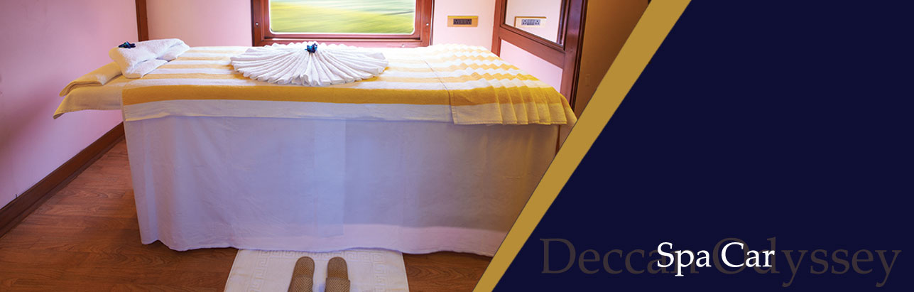
After a long day of exploration, head to Deccan Odyssey's wonderful spa "Ayush". The salon's well-trained masseurs, incorporate ancient Indian techniques to help you relax your body and rejuvenate your mind.

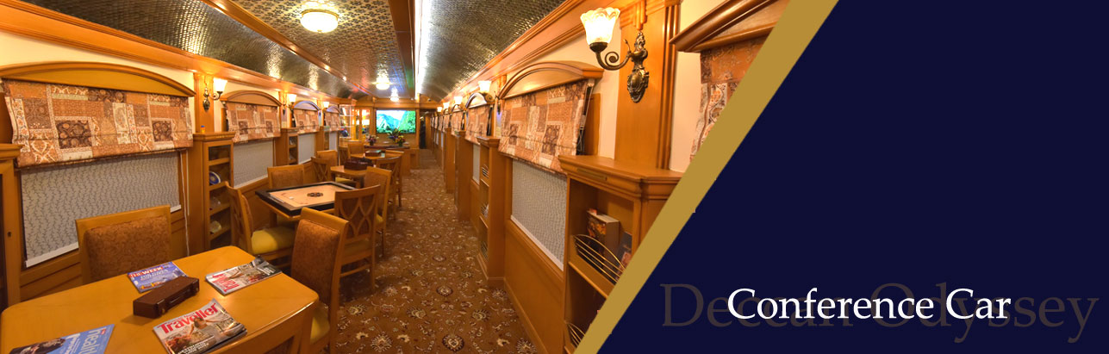
If work requires your time and attention, then our conference car, "Pankh" will take care of all your business needs. Equipped with the latest facilities, it ensures you manage your work efficiently even while you're away travelling.

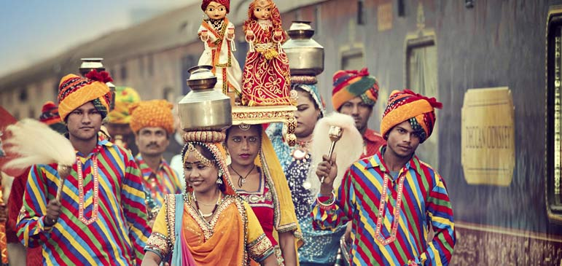
Destinations Covered:  Delhi | Agra | Sawai Madhopur | Udaipur  Jodhpur | Jaisalmer | Jaipur | Delhi | Duration:  07 Nights / 08 Days
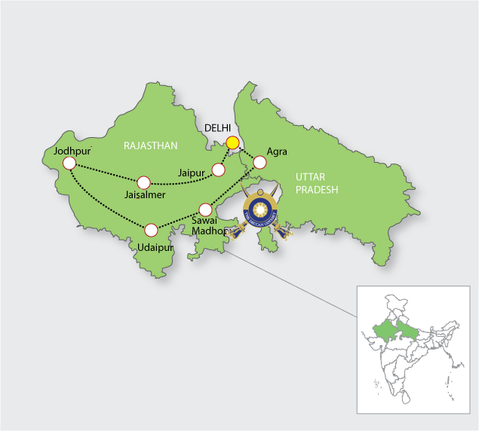

Day 1 (Saturday): DELHI  Board the Deccan Odyssey at the Delhi railway station and begin your enchanting journey, proceed to the Agra.  (Departure at 18:00) | 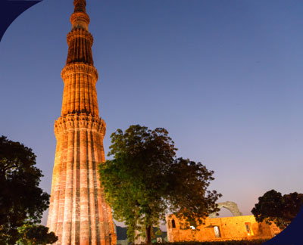
Day 2 (Sunday): AGRA  Today the Deccan Odyssey arrives at the Mughal citadel of Agra. Visit the iconic Taj Mahal, and other architectural gems of the Mughal Empire; and the impressive Agra Fort.  (Departure at 21:00) | 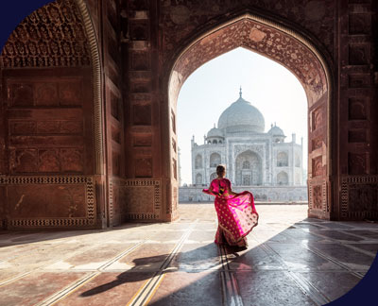
Day 3 (Monday): SAWAI MADHOPUR  Arrive at Sawai Madhopur and spend a day in the Ranthambore Tiger Reserve, once the private hunting ground of the Maharajas of Jaipur. Enjoy a village safari visit the beautiful locales of Sawai Madhopur and an adventurous jungle safari.  (Departure at 19:30) | 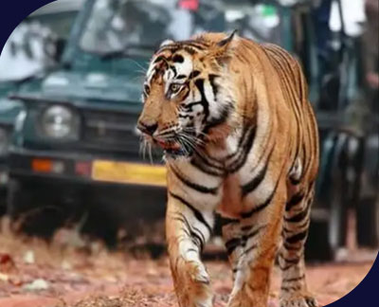
Day 4 (Tuesday): UDAIPUR  Arrive at the princely city of Udaipur. Visit the famous City Palace which houses the spectacular Crystal Gallery followed by an enthralling walk through the quaint streets of the Old City. This afternoon, be treated to a lavish lunch of local specialties at an exquisite venue..  (Departure at 21:00) | 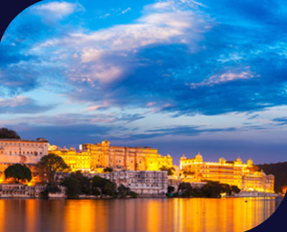
Day 5 (Wednesday): JODHPUR  On this day, you shall arrive at Jodhpur-the Blue City, Visit the imposing Mehrangarh Fort & Jaswant Thada..  (Departure at 20:00) | 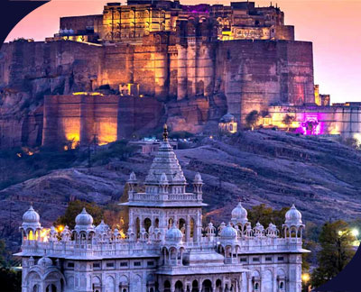
Day 6 (Thursday): JAISALMER  Arrive at Jaisalmer which is the heart of Thar Desert. Jaisalmer was founded by Rawal Jaisal in 1156 A.D. Explore the Jaisalmer city and the fort area. Enjoy the day in this beautiful desert town.  (Departure at 20:30) | 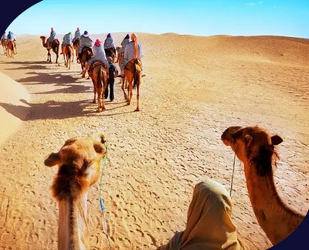
Day 7 (FRIDAY): JAIPUR  Arrive at the historic capital of Rajasthan, Jaipur, often called the Pink City. Explore the forts and palaces with a walk through the colorful bazaars of this beautiful city.  (Departure at 20:00) | 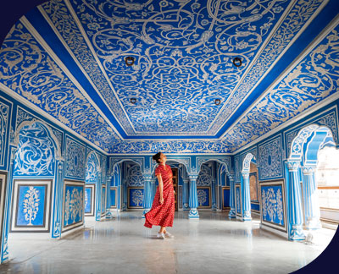
Day 8 (Saturday): DELHI  Arrive at Delhi, where your journey comes to an end. | 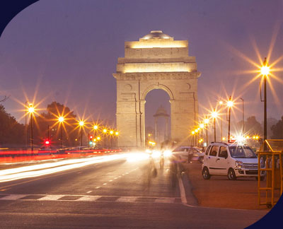

DEPARTURE DATES
2023 | 2024 | 2025
30 December | 20 January  24 February  23 March  13 April  23 November | 04 Jan  19 April

TARIFF 2023 – 2024-2025 (Per Cabin Per Journey)
Category | Single Occupancy | Double Occupancy | 02 Children  (in a separate deluxe cabin)
Deluxe Cabin | $8,330 | $11,900 | Price on Request
Presidential Suite | $17,850 | $17,850 | Price on Request

Inclusions | Exclusions
- Accommodation in double / twin bedded cabin with en suite bathrooms  - All meals (B, L, D)  - Soft beverages during the journey  - Valet service  - Still camera fees  - Guided oﬀ train excursions and game drives as illustrated in the itinerary – inclusive of entrance fees, park fees, transport and services of an English-speaking local guide | - Taxes including 5.00% (subject to change as per Govt. directives)  - Government Service tax, Insurance, gratuities  - Laundry and alcoholic Beverages  - Video and professional Still camera fees  - Arrival and Departure transfers  - International and Domestic air tickets  - Pre and Post tour accommodation and any tour extensions unless specifically mentioned as a part of the journey  - All activities mentioned as ‘options’ in the itinerary.
Booking Policy
20% of the tariff: at the time of the confirmation of the booking.
Remaining 80% of the tariff: to be paid 60 days prior to departure
Cancellation Policy
No Cancellation: cancelling 60 days prior to the departure date.
Retention of 20% of ticket value: cancelling 59 – 45 days prior to the departure date
Retention of 50% of ticket value: cancelling 44 – 30 days prior to the departure date
Retention of 100% of ticket value: cancelling 29 – 45 days prior to the departure date
Terms and Conditions
- All Costs are in USD
- The above costs are per cabin per Journey
- As the train runs on the tracks of the Indian Railways, the itineraries are subject to change in case of any changes in the routing
- Prices are subject to change in case of any amendment in the routing or other hikes such as fuel, taxes
- Children below 5 years of age shall be allowed free, subject to sharing of double bed with This is subject to availability of double bed at the time of booking
- Presidential Suite can accommodate up to 3 adults or 2 Adults and 2 children (One child up to 5 years of age and second child up to 12 years of age)
- Government Service tax of 5.00% (subject to change as per Govt. directives) is additional and will be charged extra on the published tariﬀ.
- All Departures and Arrivals are on Tentative basis and are subject to approval from Indian Railways.

