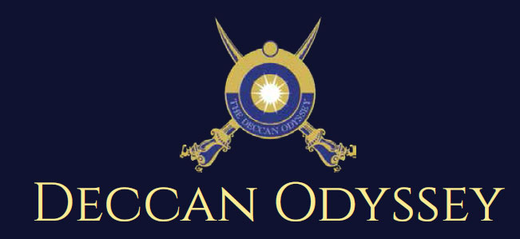

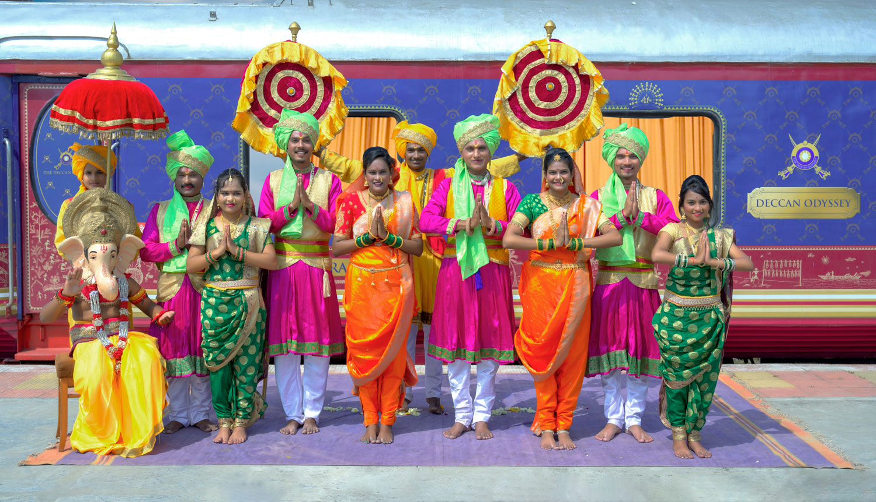

There's something unique about trains. They make you nostalgic. They transport us to far off places and we every day wake up to a new land of mystic and wonders. Trains are home to countless stories.

"Mickey Mouse popped out of my mind onto a drawing pad 20 years ago on a train ride from Manhattan to Hollywood at a time when business fortunes of my brother Roy and myself were at lowest ebb and disaster seemed right around the corner".

Walt Disney

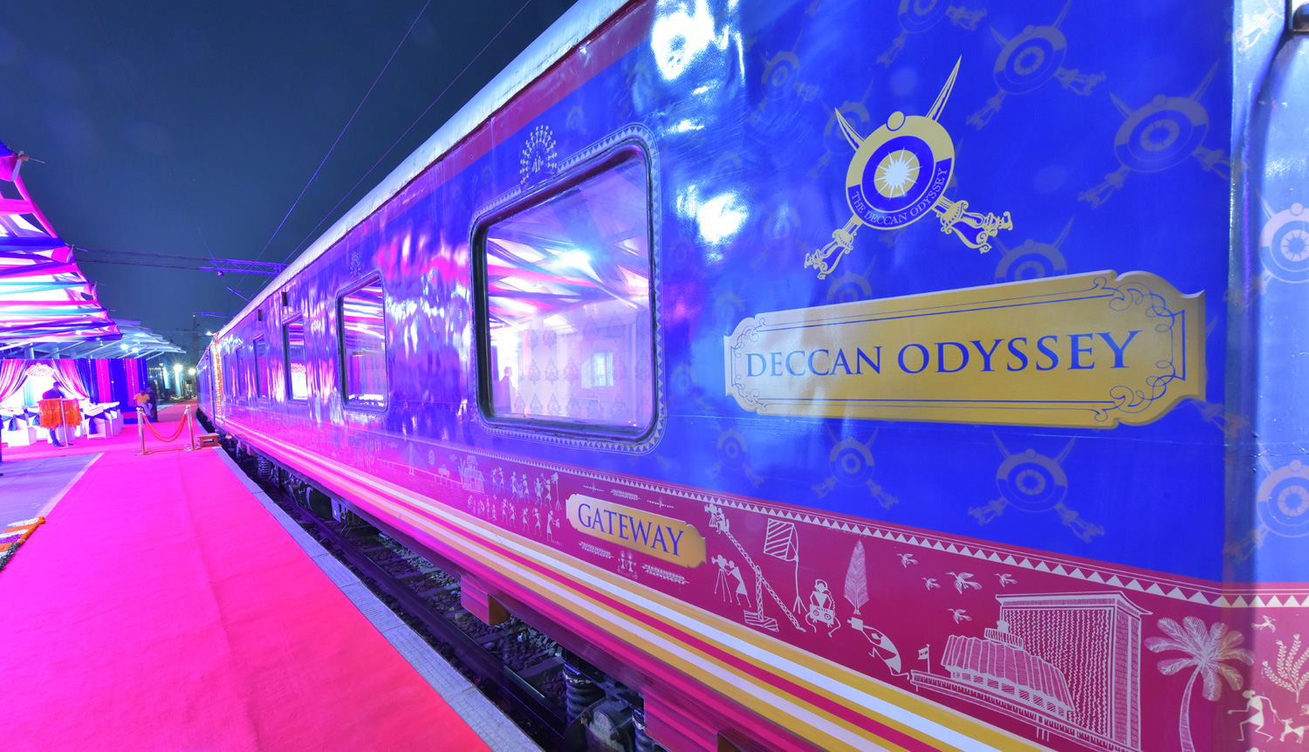

A journey that remains, magical and memorable. The Deccan Odyssey Train Routes and journeys designed to discover the art, architecture, culture, history and wildlife in style. Choose from set of excellent journeys that take you through different parts of India.

TRAIN LAYOUT
Passenger Cars (4 Coupes per Coach) (10)
Presidential Suite Cars (2 Coupes per Coach) (02)
Conference Car with Business Centre (01)
Restaurant Cars (02)
Staff, spare car (02)
Spa Car (01)
Bar Car (01)
Generator Cars with Luggage Store (02)
Total Coaches- 21 -
It can accommodate 88 guests at a time

PRESIDENTIAL SUITE

Dimensions  Cabin Area: 191 Sq Ft  Cabin Length: 8.4 meter  Cabin Width: 2.3 meter  Bed Length: 2.0 meter  Bed Width:0.9 meter  Cabin per Coach: 2 | Private attached bathroom with shower; channel music facility; Individual temperature control panel; direct dial telephone; electronic safe & small cupboard; Presidential suite cabins have a master bedroom with spacious living area, two bathrooms, Personal butler available in each sleeper carriage 24hrs.

DELUXE CABIN

Dimensions  Cabin Area: 95 Sq Ft  Cabin Length: 3.97 meter  Cabin Width: 2.3 meter  Bed Length: 2.0 meter  Bed Width:0.9 meter  Cabin per Coach: 4 | Deluxe Coach features 4 Double/ Twin bed cabins. Direct dial phone, electronic safe, and individual climate control facility. Bathrooms come fitted with wash basin & shower, shower cubicle and running hot and cold water; Twin bed is 6' x 3'. Specially equipped cabin, for the comfort of our diﬀerently-abled guests.

RESTAURANTS

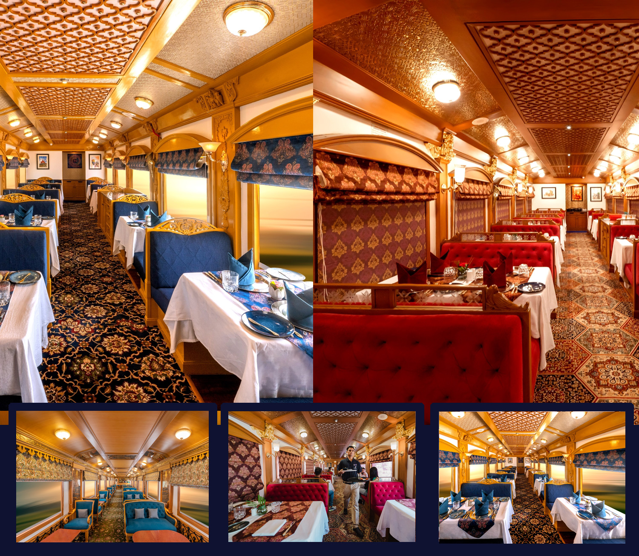
The Deccan Odyssey's two gourmet restaurants, Waavar and Utsav have been designed to keep the element of Indian royalty intact. Our chefs ensure the cuisine keeps pace with the train's journey, by creating local specialties of the every state that the train travels through. So you discover every location with all your senses, including your taste buds! Each meal also includes an International menu to choose from. To further enhance the gourmet experience, Deccan Odyssey presents travelers with a well-stocked bar - Gateway. This is the ideal spot to meet and know your fellow travelers, over an evening drink & snacks.

GATEWAY BAR
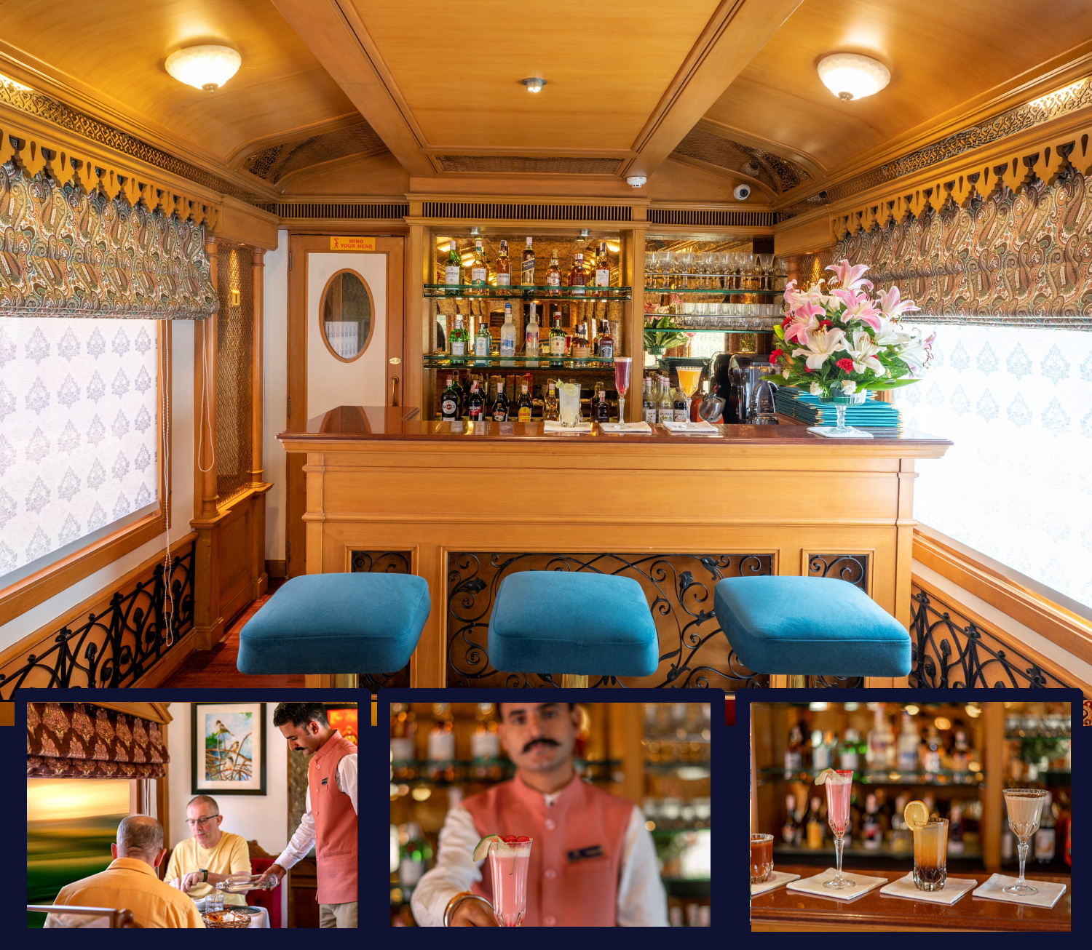
A Well-Stocked Bar with TV Facility serves Wine, Liquor and Spirits of Indian and International make.

CONFERENCE CAR
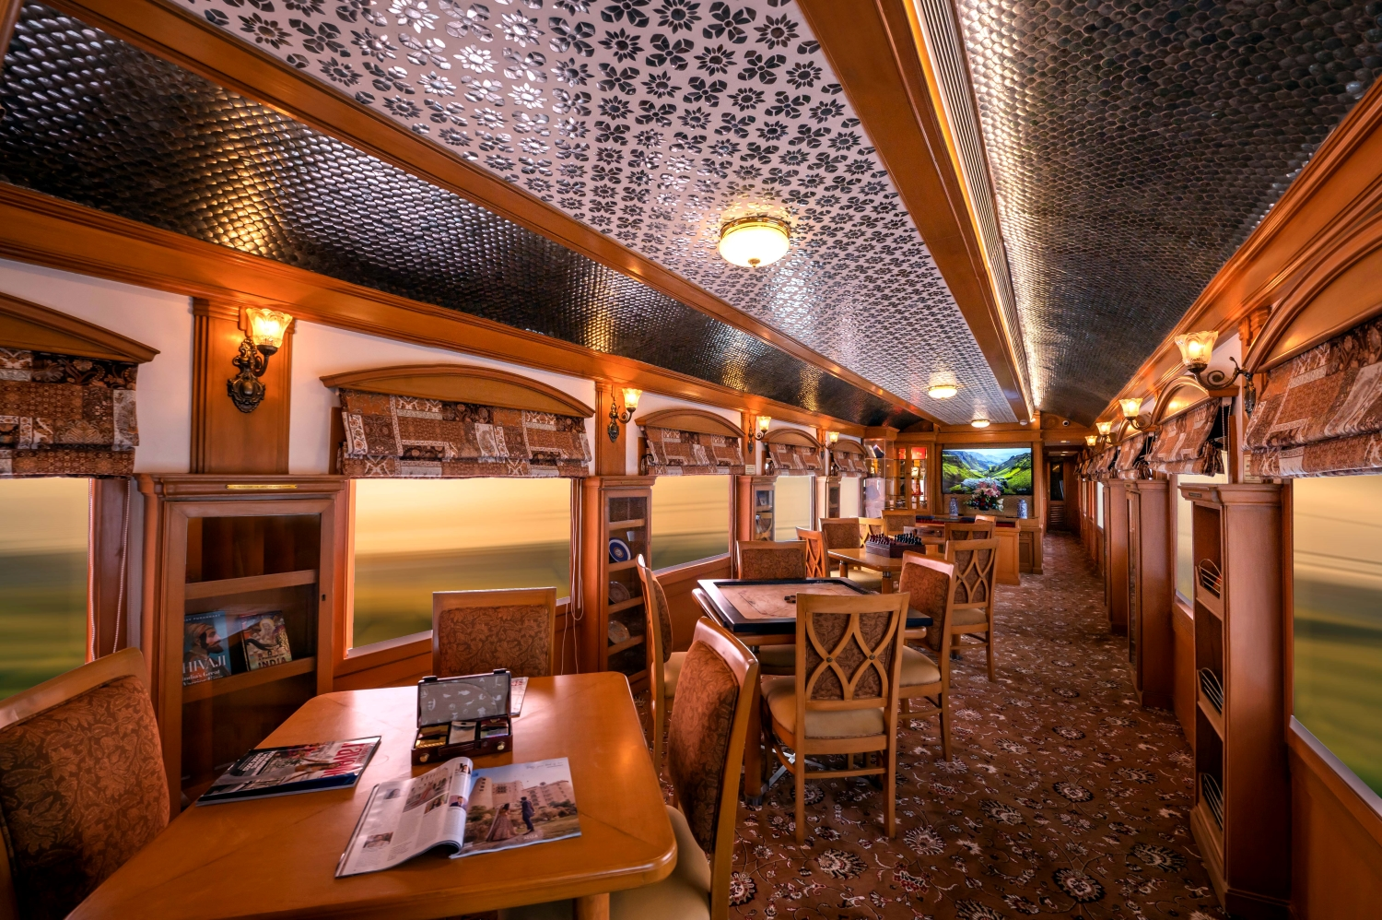
If work requires your time and attention, then our conference car, "Pankh" will take care of all your business needs. Equipped with the latest facilities, it ensures you manage your work efficiently even while you're away travelling.

SPA CAR

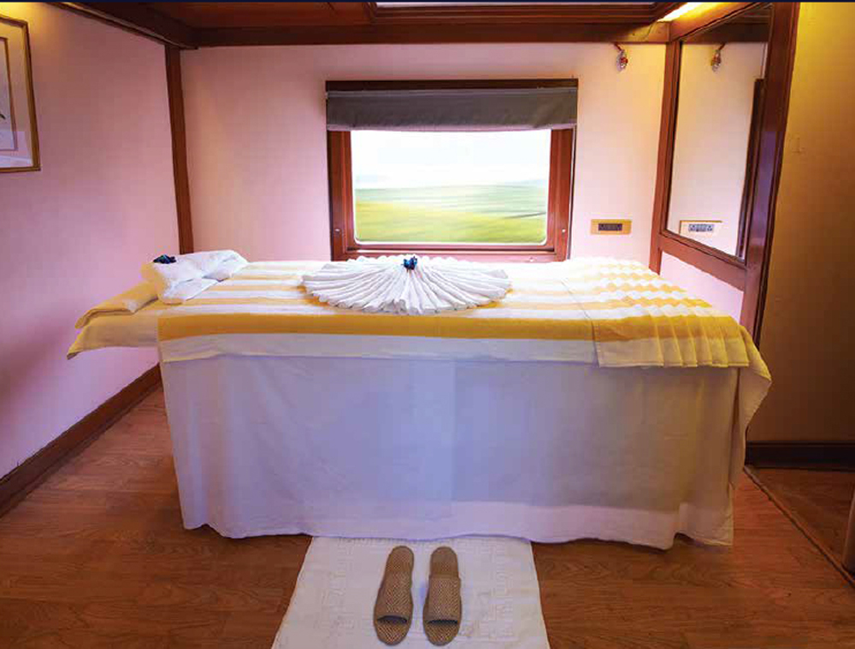

After a long day of exploration, head to Deccan Odyssey's wonderful spa "Ayush". The salon's well-trained masseurs, incorporate ancient Indian techniques to help you relax your body and rejuvenate your mind.

CULTURAL ODYSSEY ITINERARY

Duration:

Delhi | Sawai Madhopur | Jaipur | Agra | Gwalior | Orchha | Khajuraho | Varanasi | Delhi
07 Nights / 08 Days

CULTURAL ODYSSEY
Day 1 (Saturday): DELHI
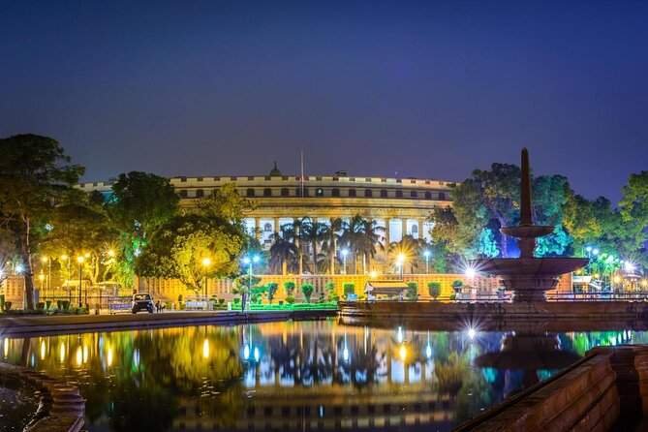
Board the Deccan Odyssey at Delhi – on to Sawai Ranthambore

Welcome aboard the Deccan Odyssey.

This evening assemble at the railway station at approximately 1700 hours to complete the registration process and check in formalities for your Indian Odyssey journey, as you receive a traditional Indian welcome and enjoy a refreshing welcome drink.

After completion of all formalities, you will be shown to your delightful cabins. As you settle in, the Deccan Odyssey shall depart Delhi for Sawai Madhopur.

Overnight on Deccan Odyssey
(ETD at 1815 Hrs)

Day 2 (Sunday): SAWAI MADHOPUR
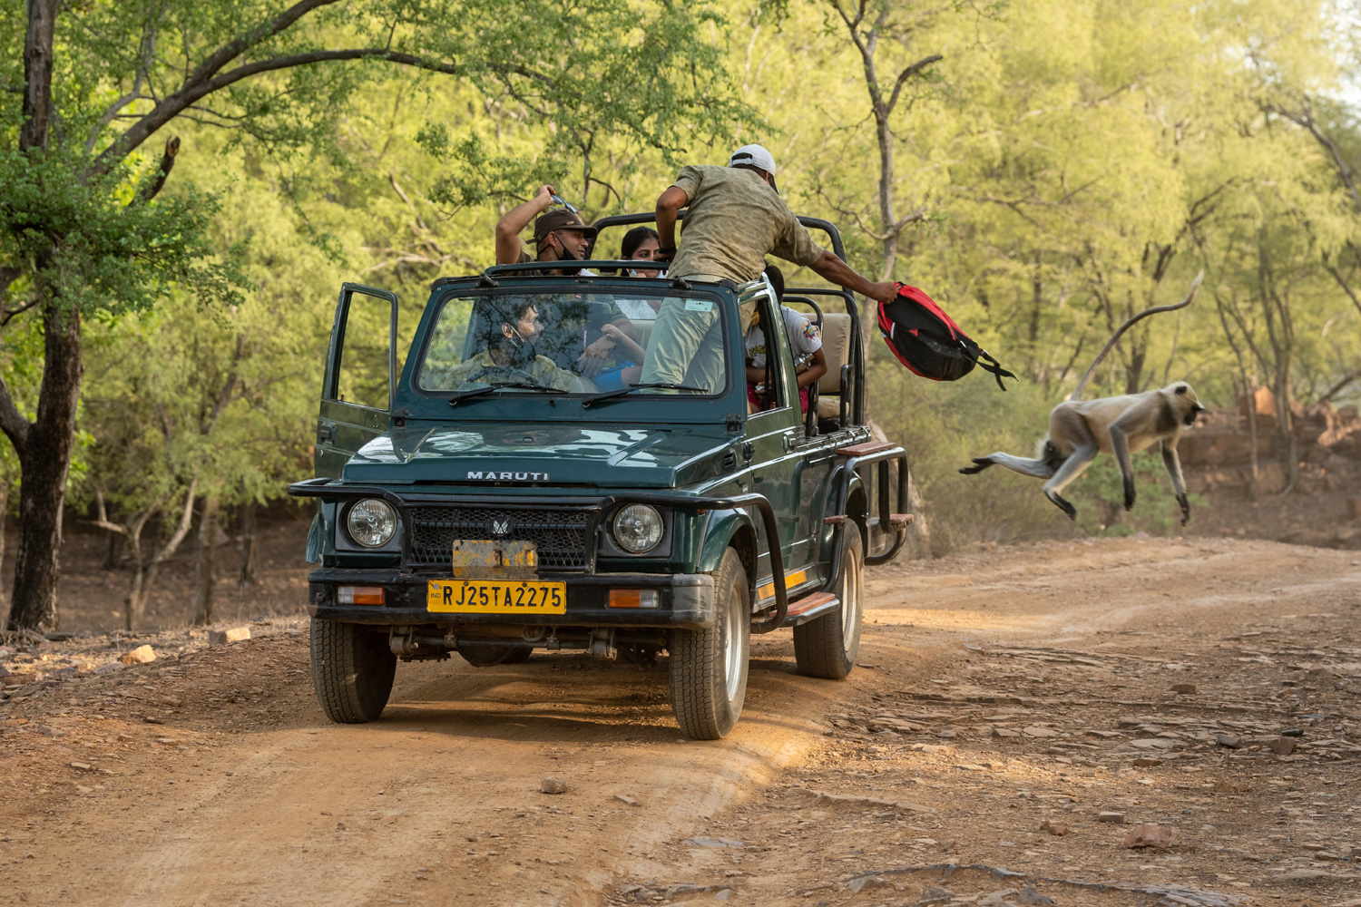
Sawai Madhopur, in Rajasthan is the alighting point for the famous Ranthambore National Park, and India’s efforts to conserve the dwindling tiger population can be seen here.

Enjoy breakfast before your morning village safari. Visit a local home for a and interact with the family. Post the village tour head back to the comfort of Deccan Odyssey for asumptuous lunch.

Post lunch, disembark to head for the afternoon safari.

Return to Deccan Odyssey, dinner on board, and your onward journey to Jaipur, The Pink City.

Breakfast, Lunch & Dinner on board;

Overnight on Deccan Odyssey
(ETD at 2030 Hrs)

Day 3 (Monday): JAIPUR
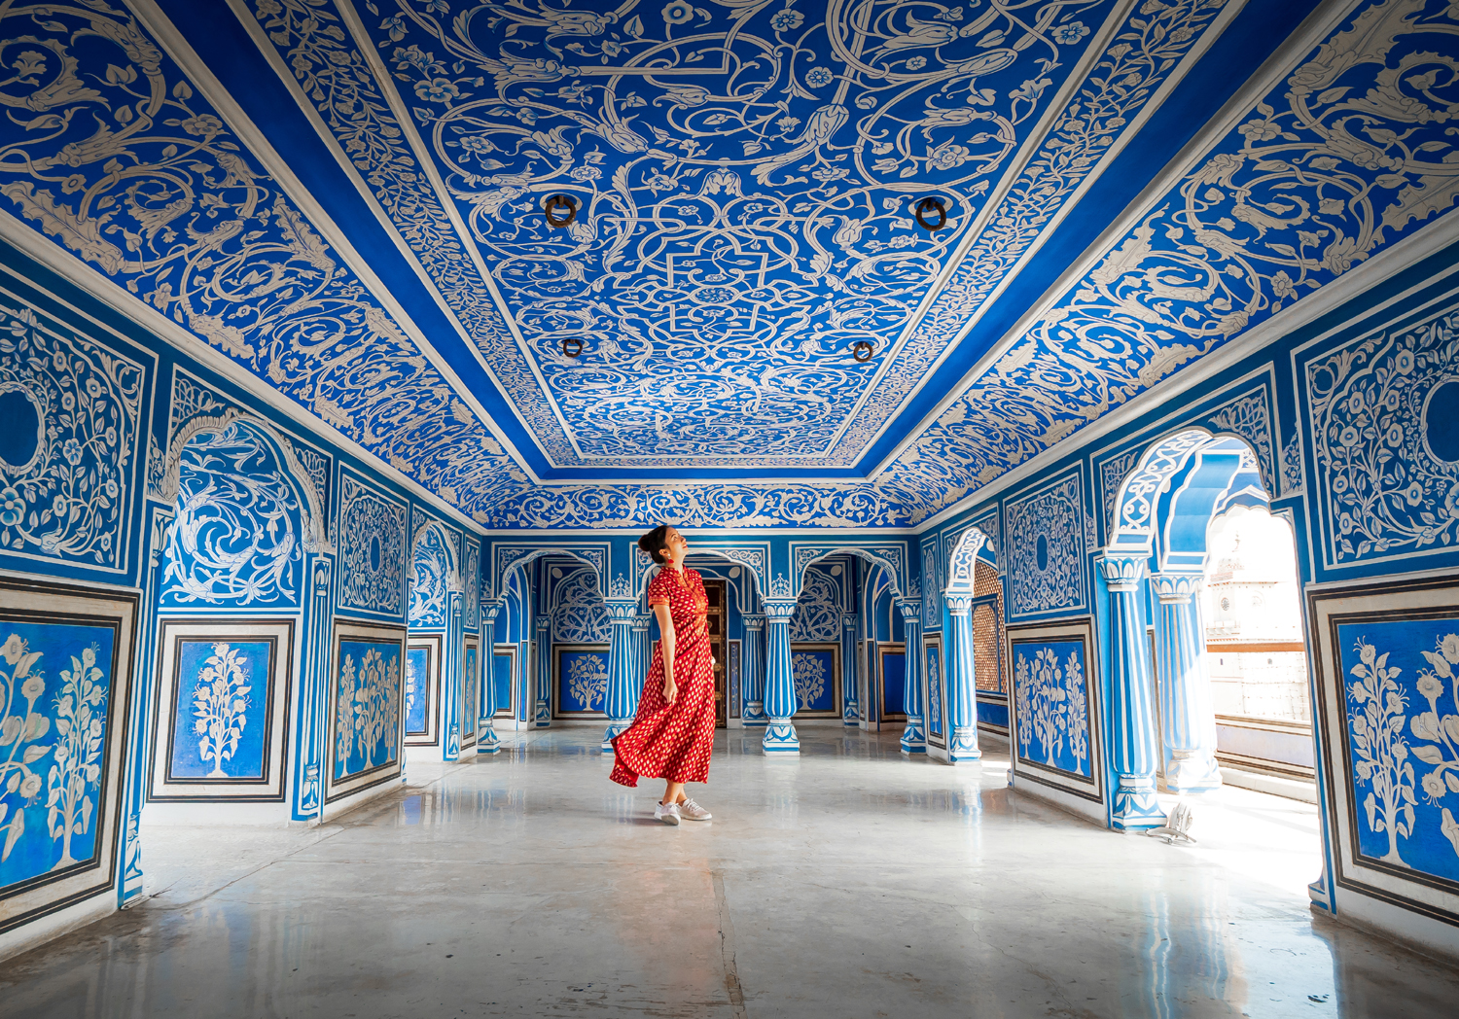
After breakfast you drive to Maharaja Mansingh’s 17th century masterpiece, the Amber Fort that overlooks the beautiful Maota Lake. En-route to Amber Fort visit the Palace of Winds, otherwise known as the Hawa Mahal, famous for its intricate pink sandstone carving and a beautiful view of the city.

Thereafter you will visit the famous City Palace of Jaipur, an overwhelming complex of exquisite palaces, gardens and courtyards, decorative art and carved doorways.

Lunch at a City hotel. Following lunch you may choose to participate in shopping experience.
After your full day of delving in the royal past of Jaipur you will return to the Deccan Odyssey for dinner on board as it departs for Agra.

Breakfast on board, Lunch at a City hotel & Dinner on board

Overnight on Deccan Odyssey
(ETD at 1800 Hrs)

Day 4 (Tuesday): AGRA
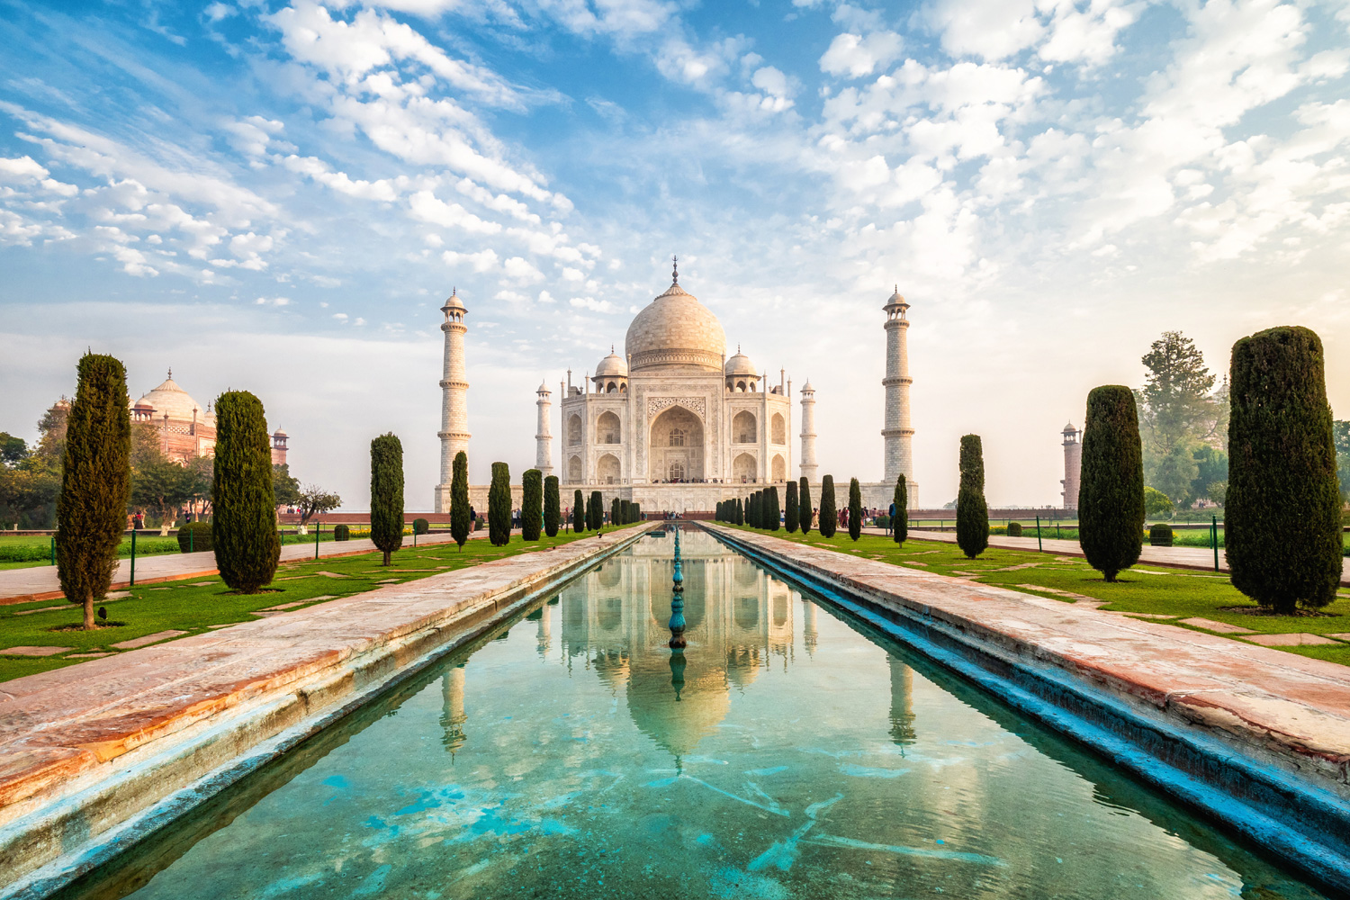
Arriving at Agra.

After Breakfast proceed for Taj Mahal Sightseeing.
Lunch at a City Hotel.

After lunch visit to Agra Fort, A visit to the Diwan-e-Am, ‘Hall of Public Audience’ and the Royal Pavilions is not to be missed.

Later, you have the opportunity to visit the local showroom to admire the exquisite Pietra Dura (marble inlay) artefacts and Mughal ornaments.

Late evening, you return to the Deccan Odyssey sets off for Gwalior.

Breakfast on board, Lunch at a City Hotel & Dinner on board

Overnight on Deccan Odyssey
(ETD at 2100 Hrs)

Day 5 (WEDNESDAY): GWALIOR - ORCHHA
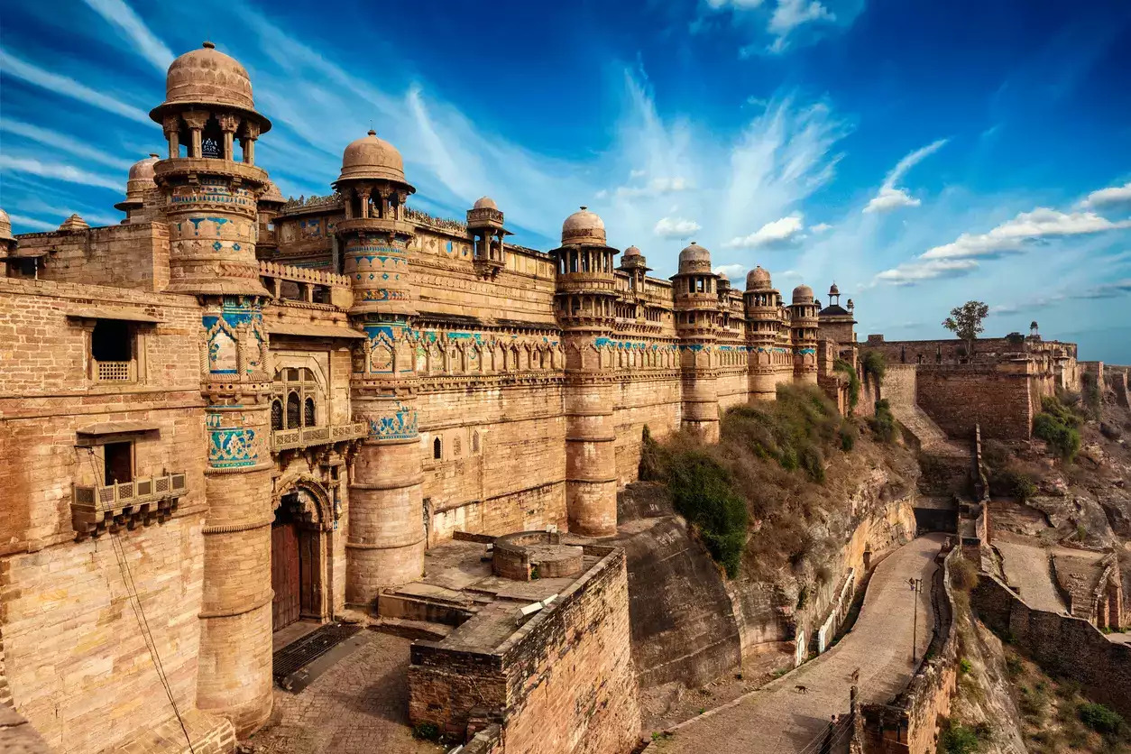
Today the Deccan Odyssey arrives at Gwalior, visit the Majestic Gwalior fort. Later board the train for Orchha. Visit the fort, visit the Temple, and experience village life as well.

Breakfast on board, Lunch at a City Hotel & Dinner on board

Overnight on Deccan Odyssey
(ETD at 2030 Hrs)

Day 6 (Thursday): KHAJURAHO
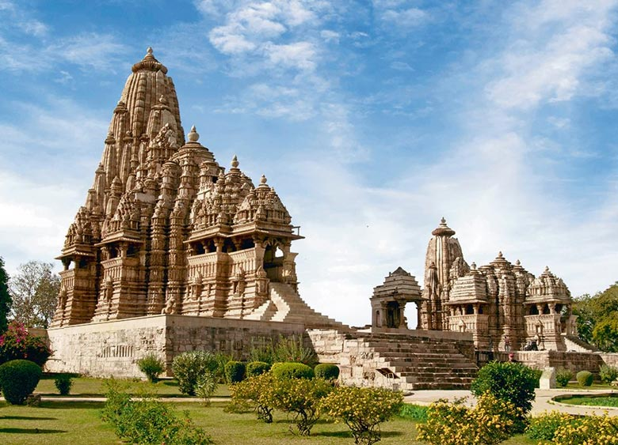
Arrive at the historic city of Khajuraho, which beholds the World Heritage Monument the Chandela Temple complex. Visit the Mahadev Temple.

Breakfast on board, Lunch at a City Hotel & Dinner on board

Overnight on Deccan Odyssey
(ETD at 2000 Hrs)

Day 7 (FRIDAY): VARANASI
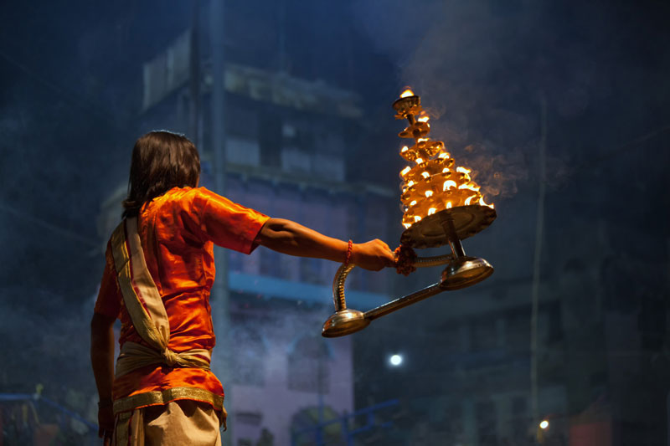
Arrive at Varanasi - The cradle of Mankind the oldest living city on this planet. Visit Temples & Ghat area, experience the lively bazaar and the mystic chaos. Enjoy a boat ride on the Holy Ganges.

Breakfast on board, Lunch at a City Hotel & Dinner on board

Overnight on Deccan Odyssey
(ETD at 2000 Hrs)

Day 8 (Saturday): DELHI
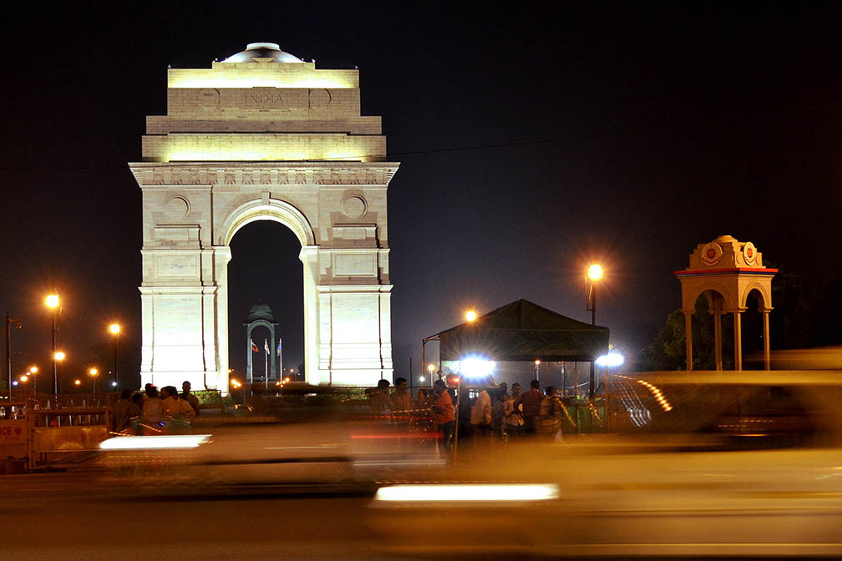
Disembark in Delhi

Early this morning, after breakfast, you will disembark at the Delhi Safdarjung Station.

Bid farewell to the Deccan Odyssey as your royal passage through the grand vistas of India comes to an end.

Breakfast on board

DEPARTURE DATES
2023 | 2024 | 2025 | 2026
25 November | 02 March  30 November  28 December | 08 March  29 November  27 December | 07 March

TARIFF 2023 –2024 (Per Cabin Per Journey)
Category | Single Occupancy | Double Occupancy | 02 Children  (in a separate deluxe cabin)
Deluxe Cabin | $8,330 | $11,900 | Price on Request
Presidential Suite | $17,850 | $17,850 | Price on Request

TARIFF 2024-2025 (Per Cabin Per Journey)
Category | Single Occupancy | Double Occupancy | 02 Children  (in a separate deluxe cabin)
Deluxe Cabin | $8,330 | $11,900 | Price on Request
Presidential Suite | $17,850 | $17,850 | Price on Request

TARIFF 2025-2026 (Per Cabin Per Journey)
Category | Single Occupancy | Double Occupancy | 02 Children  (in a separate deluxe cabin)
Deluxe Cabin | $9,330 | $13,300 | Price on Request
Presidential Suite | $20,000 | $20,000 | Price on Request

Inclusions | Exclusions
- Accommodation in double / twin bedded cabin with en suite bathrooms  - All meals (B, L, D)  - Soft beverages during the journey  - Valet service  - Still camera fees  - Guided oﬀ train excursions and game drives as illustrated in the itinerary – inclusive of entrance fees, park fees, transport and services of an English-speaking local guide | - Taxes including 5.00% (subject to change as per Govt. directives)  - Government Service tax, Insurance, gratuities  - Laundry and alcoholic Beverages  - Video and professional Still camera fees  - Arrival and Departure transfers  - International and Domestic air tickets  - Pre and Post tour accommodation and any tour extensions unless specifically mentioned as a part of the journey  - All activities mentioned as ‘options’ in the itinerary.
Booking Policy
20% of the tariff: at the time of the confirmation of the booking.
Remaining 80% of the tariff: to be paid 60 days prior to departure
Cancellation Policy
Retention of 10% of ticket value: cancelling 60 days prior to the departure date.
Retention of 20% of ticket value: cancelling 59 – 45 days prior to the departure date
Retention of 50% of ticket value: cancelling 44 – 30 days prior to the departure date
Retention of 100% of ticket value: cancelling 29 – 45 days prior to the departure date
Terms and Conditions
- All Costs are in USD
- The above costs are per cabin per Journey
- As the train runs on the tracks of the Indian Railways, the itineraries are subject to change in case of any changes in the routing
- Prices are subject to change in case of any amendment in the routing or other hikes such as fuel, taxes
- Children below 5 years of age shall be allowed free, subject to sharing of double bed with This is subject to availability of double bed at the time of booking
- Presidential Suite can accommodate up to 3 adults or 2 Adults and 2 children (One child up to 5 years of age and second child up to 12 years of age)
- Government Service tax of 5.00% (subject to change as per Govt. directives) is additional and will be charged extra on the published tariﬀ.
- All Departures and Arrivals are on Tentative basis and are subject to approval from Indian Railways.
- The Entire Deccan Odyssey Train is non Smoking. For any particular requirement, kindly contact your Valet.
- We need minimum occupancy to operate all listed journeys, in event if we do not manage minimum occupancy we reserve the right to cancel the journey at least with 30 days prior intimation.
- As Train runs on tracks so you may experience sounds of passing trains and some shaking during the journey. This is a normal feature countrywide with trains in India.
- Paramedic on Board
